**NAIVE BAYES**

**CONDITIONAL PROBABILITY**

**INDEPENDENT AND MUTUALLY EXCLUSIVE EVENTS**

**BAYES THEOREM**

**NAIVE BAYES**

**TOY EXAMPLE - NAIVE BAYES**

**NAIVE BAYES ON TEXT DATA**

**LAPLACE ADDITIVE SMOOTHING**

**LOG - PROBABILITIES FOR NUMERICAL STABILITY**

**BIAS-VARIANCE TRADEOFF**

**FEATURE IMPORTANCE AND INTERPRETABILITY**

**OUTLIERS**

**MISSING VALUES**

**GAUSSIAN NAIVE BAYES**

**BEST AND WORSE CASES FOR NAIVE BAYES**

# **CONDITIONAL PROBABILITY**

Naive Bayes is a classification algorithm based on the basics of Probability

We have two dices $D_{1}$ and $D_{2}$. So together they can take 36 values. One dice has 6 outcomes. So their combined outcome is 6 * 6 = 36 .Eg - (1,1), (1,2), (1,3)...(2,1), (2,2)...(6,6)

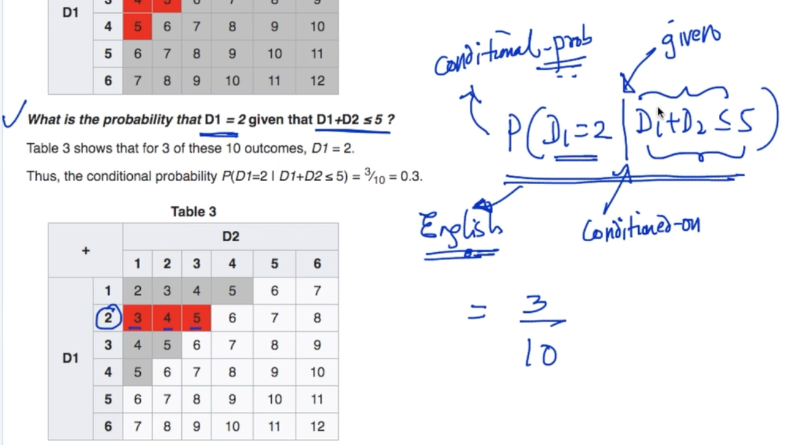

The above equation is the equation of conditional probability. Let’s try to interpret it in English, it says that what is the Probability that $D_{1}$ = 2 given $D_{1}+D_{2}$ $≤$ 5 .

So, P ( $D_{1}+D_{2}$ $≤$ 5) = 10/36 and P ($D_{1}=2$) = 3/36

Definition :- P (A | B) = $\frac{P (A ∩ B)}{P(B)}$ here A : $D_{1}=2$ and B : $D_{1}+D_{2}≤5$

Using this equation we can get our answer which is 3/10

[Conditional probability - Wikipedia](https://en.wikipedia.org/wiki/Conditional_probability)

# **INDEPENDENT AND MUTUALLY EXCLUSIVE EVENTS**

**INDEPENDENT EVENTS**

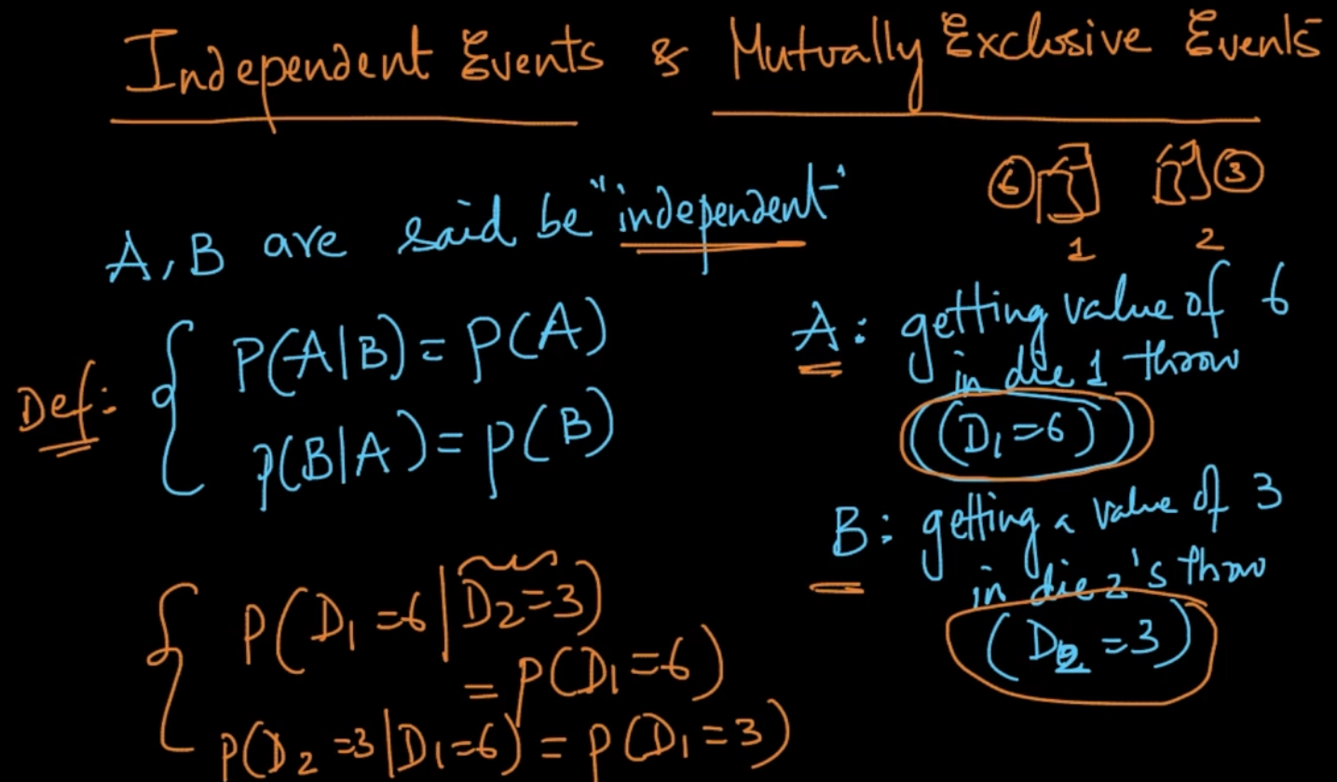

A, B are said to be independent if a probability of event A is not dependent on event B

Take the example of 2 dices above thrown.Their outcomes are independent obviously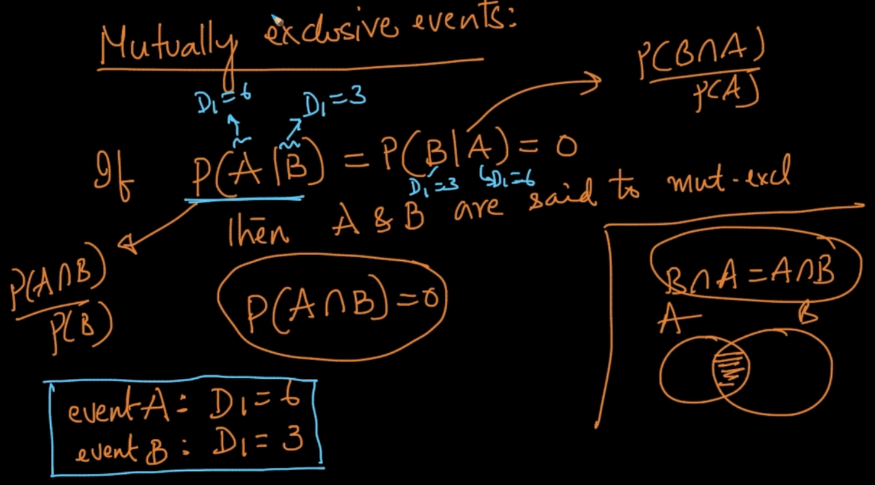

In P (A | B) = 0 because if it’s given D1 = 3 (B) then there’s no chance of A : D1 = 6 happening .Vice versa is also true here. So, they are mutually exclusive events P(A $∩$ B) =0

# **BAYES THEOREM**

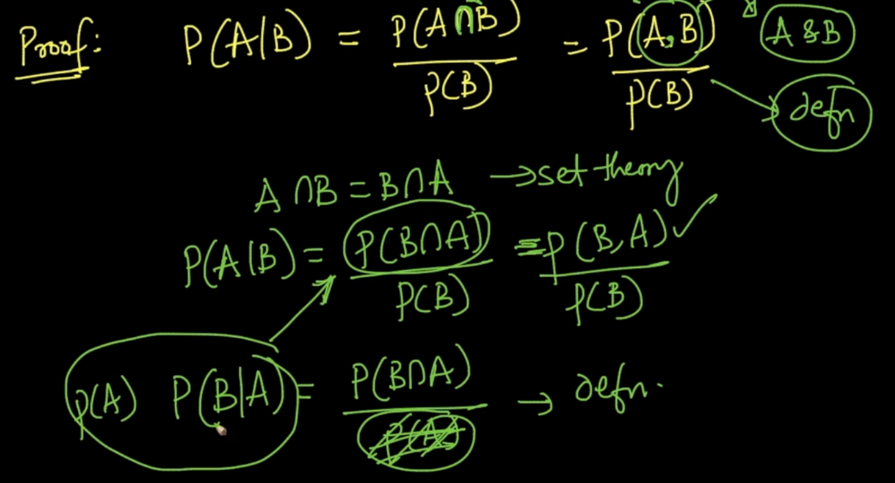

Here, P (A | B) = $\frac{P(B ∩ A)}{P(B)}$ and P(B | A) = $\frac{P(B ∩ A)}{P(A)}$ and it’ll be P(B $∩$ A) = P (A). P(B | A)

Therefore, P (A | B) = $\frac{P(B | A) P(A)}{P(B)}$ which is Bayes’ theorem

# **NAIVE BAYES**

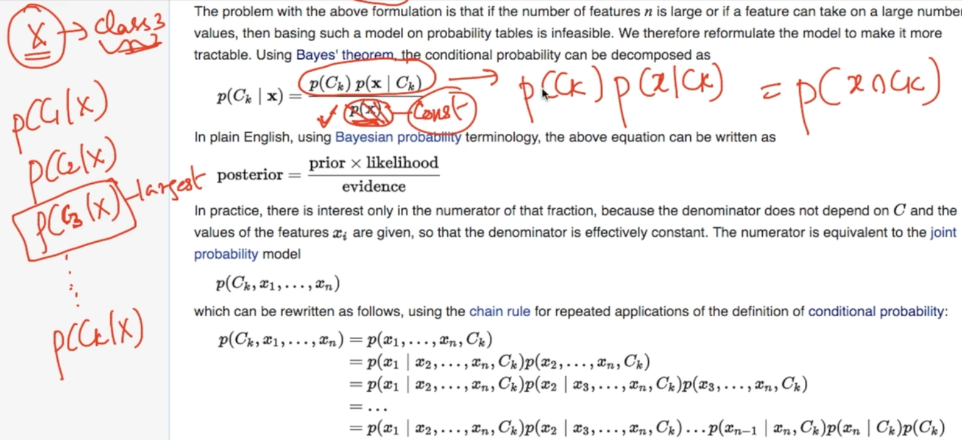

1 ) Naive Bayes is based on Bayes’ theorem . Here we are given x and we want to predict class label $C_{k}$ i.e P($C_{k} | x$).

2 ) We are given x and we are predicting class $C_{k}$ from multiclasses. Whichever class’ probability is largest is selected

3) In P() = numerator can be ignored because x is given so it’s a constant

So , P($C_{k} | x$) $∝$ p($C_{k}$) p(x | ). This numerator is called joint probability model.

p($C_{k}$) p(x | ) => p($C_{k}∩x$) = p( $C_{k},$ x1,x2…..xn)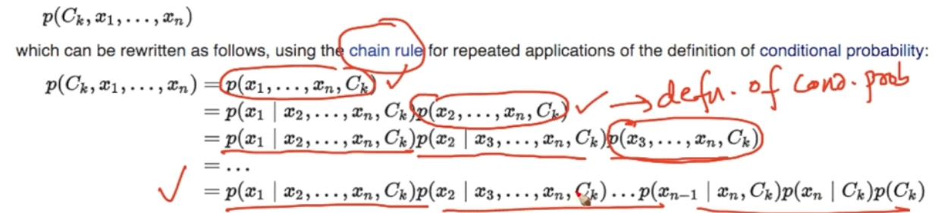

For every x probability is calculated

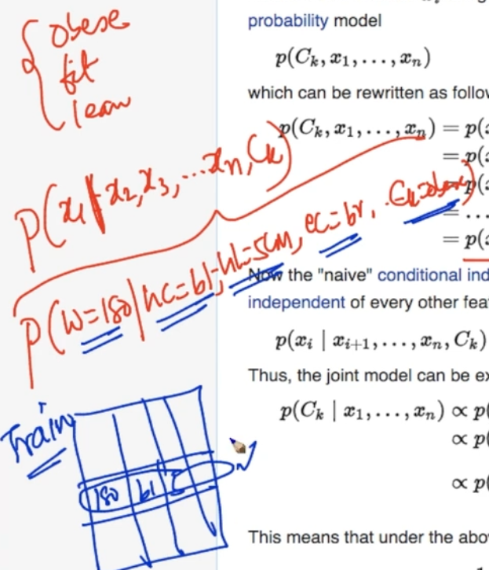

We want to predict body type given body features. Here, it is extremely rare to find class labels with exact features given above.

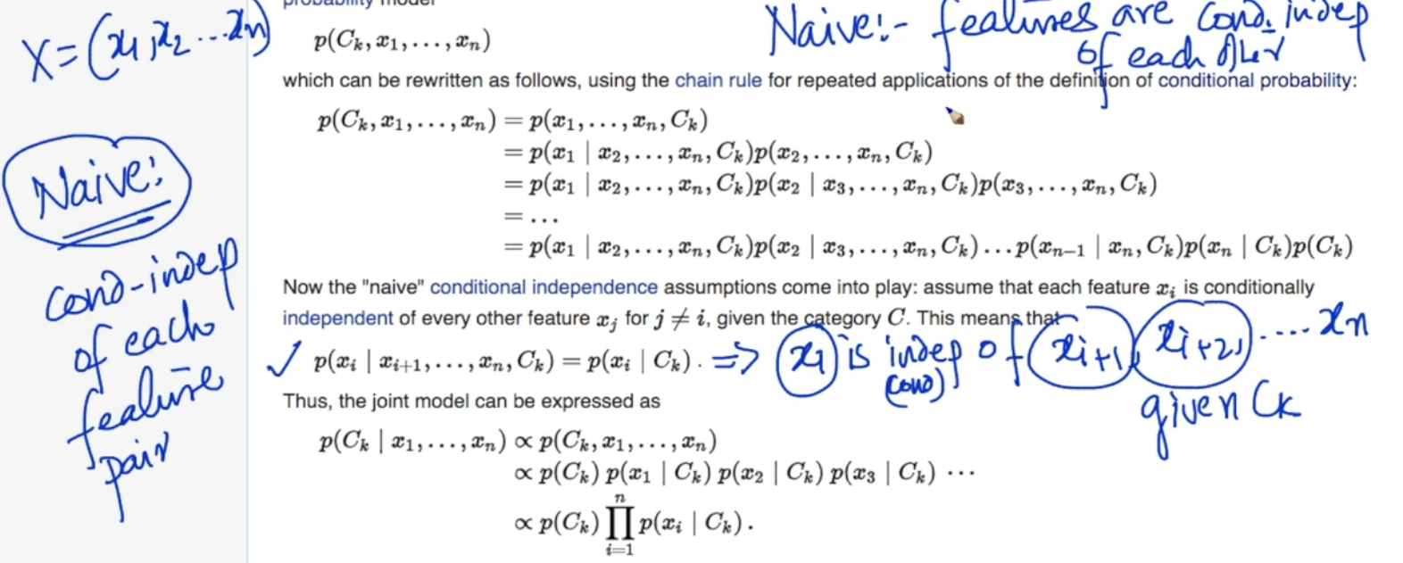

If P(A | B,C) = P(A | C) the A is conditionally independent from B. This approach is used Naive Bayes which makes the math easier i.e P( $x_{1}| x_{2},x_{3}....C_{k}$) = P($x_{1}| C_{k}$)

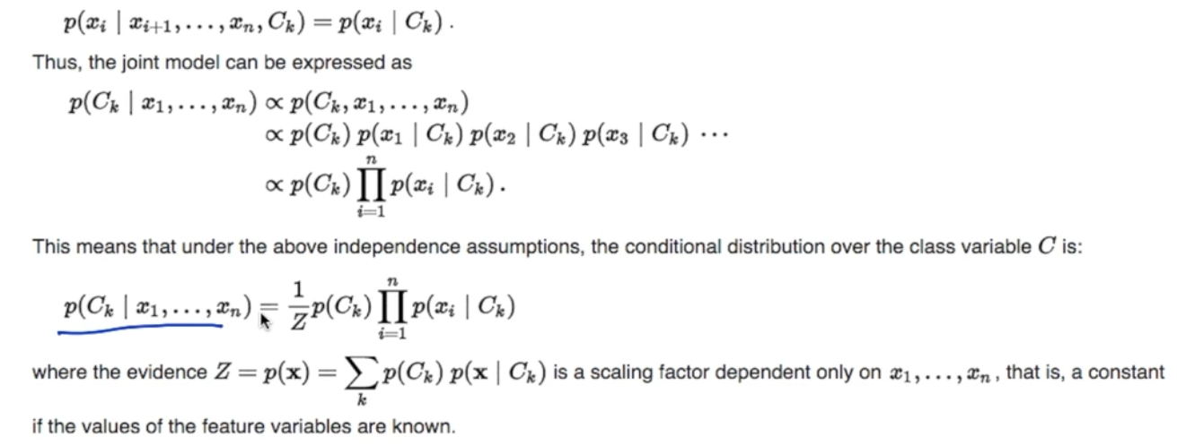

So P($C_{k} | x$) $∝$ p($C_{k}$) p(x | ) where x = x1,x2,x3...xn can be represented like above stands for multiplication just like

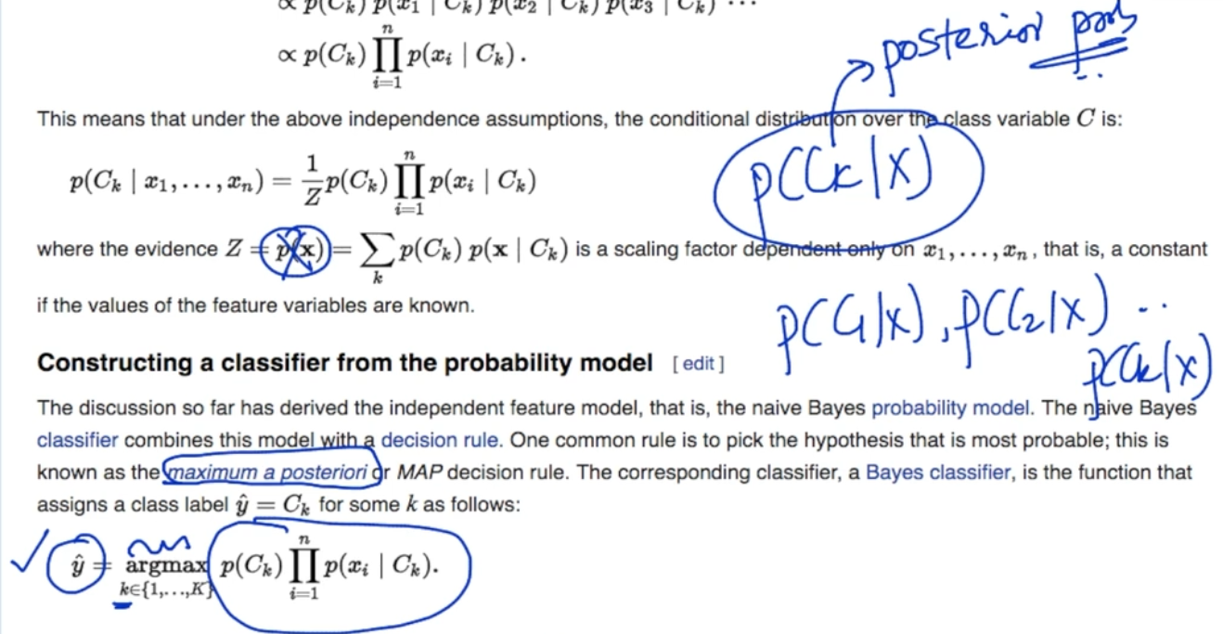

To predict class label $\hat{y}$ we want the maximum of the above equation

[Naive Bayes classifier - Wikipedia](https://en.wikipedia.org/wiki/Naive_Bayes_classifier)

# **TOY EXAMPLE - NAIVE BAYES**

This is Binary Classification with the help of categorical feaures .

We want to predict if match can be played using class Plays given a new query $x_{q}$ with features.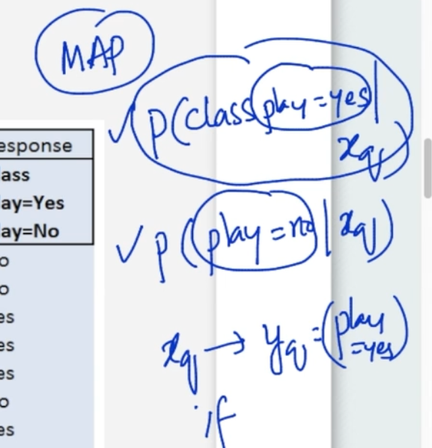

We are in the learning phase, and we want to calculate likelihoods . What are likelihoods?They are probability of a feature given a class label.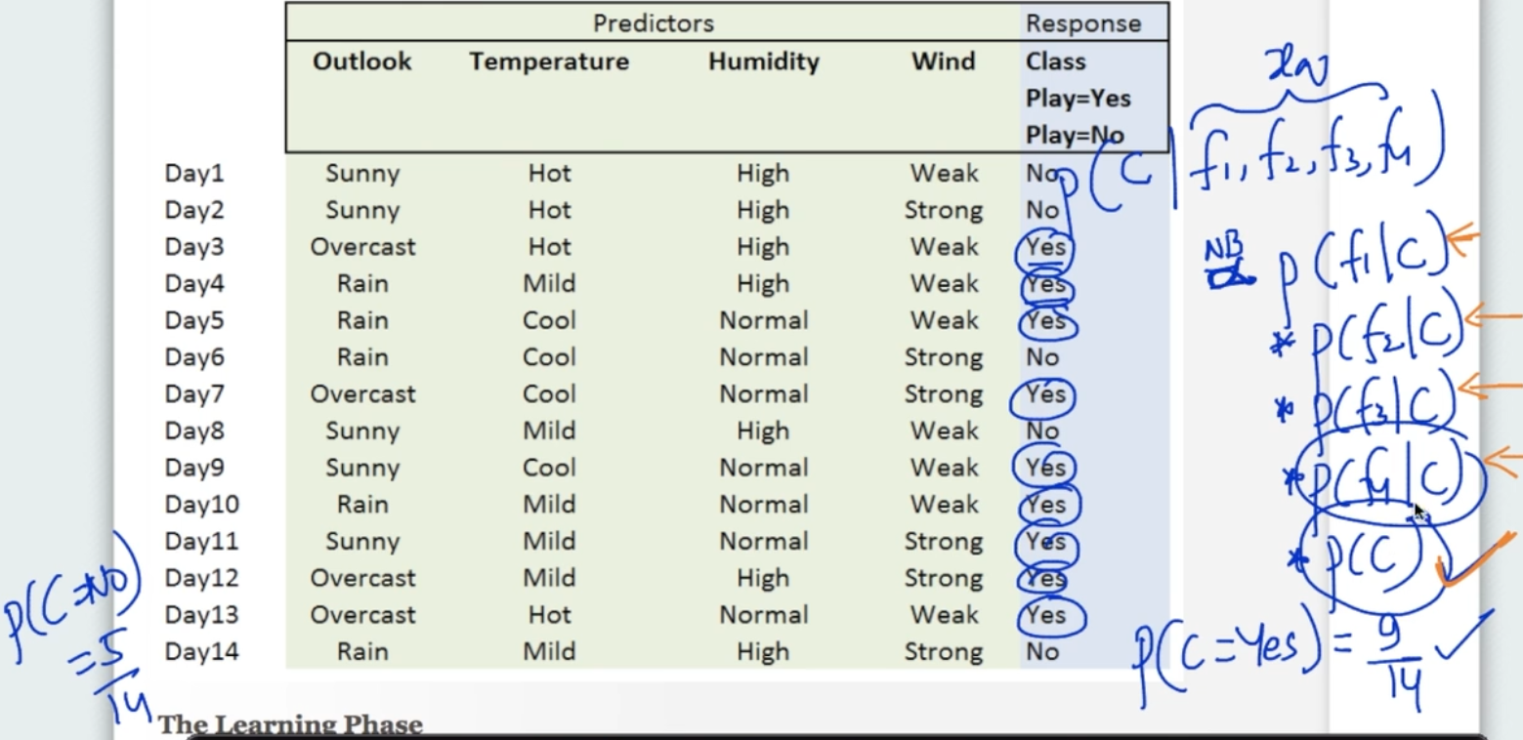

We want to calculate P(C | ) where C is class label and f is feature of a query $x_{q}$

It is proportionate to P(| C) * P(C). P(C) is easy to calculate. P(C = Yes) = Total no. of yes in class / Total no. of class labels = 9/14.

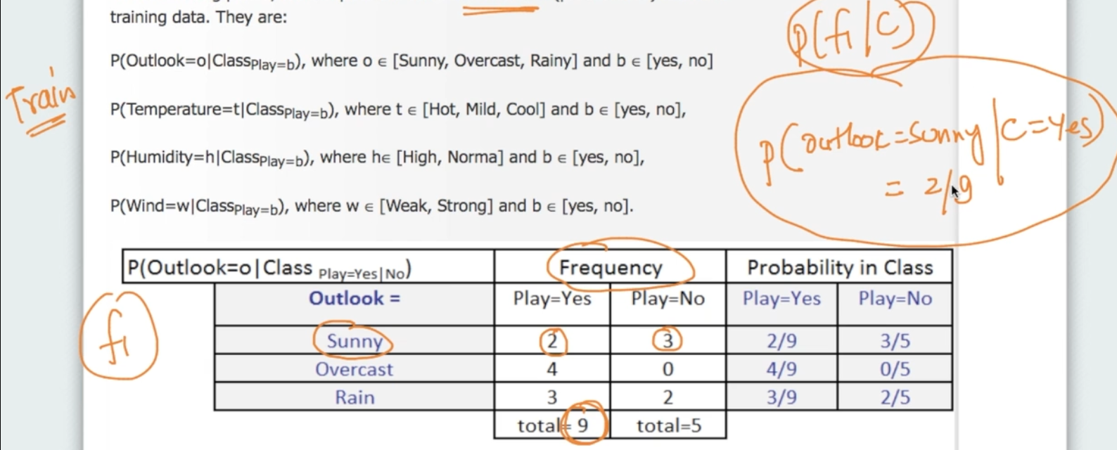

In the training phase ,we calculate the frequencies. Above for feature $f_{1}$ = Outlook we are calculating P( $f_{1}| C$). P (outlook = Sunny | C = Yes) = 2/9 since Outlook = Sunny is occurring 2 times in total Yes which is 9. We need to calculate it for every feature

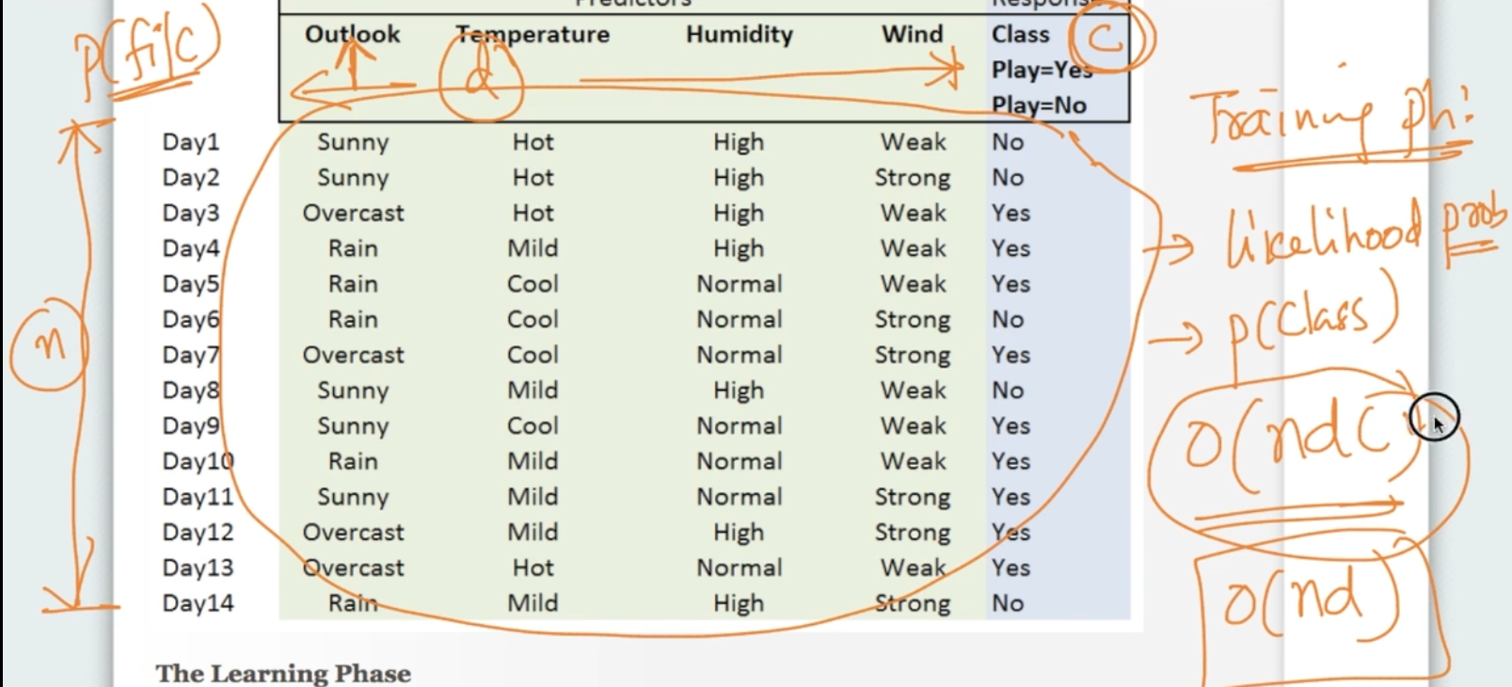

Time Complexity : O(ndc) where n- Number of inputs, d- dimensions ,C - No. of classes

Space Complexity : O(d * c) because for every d- dimensional feature we need to store

P(f | c)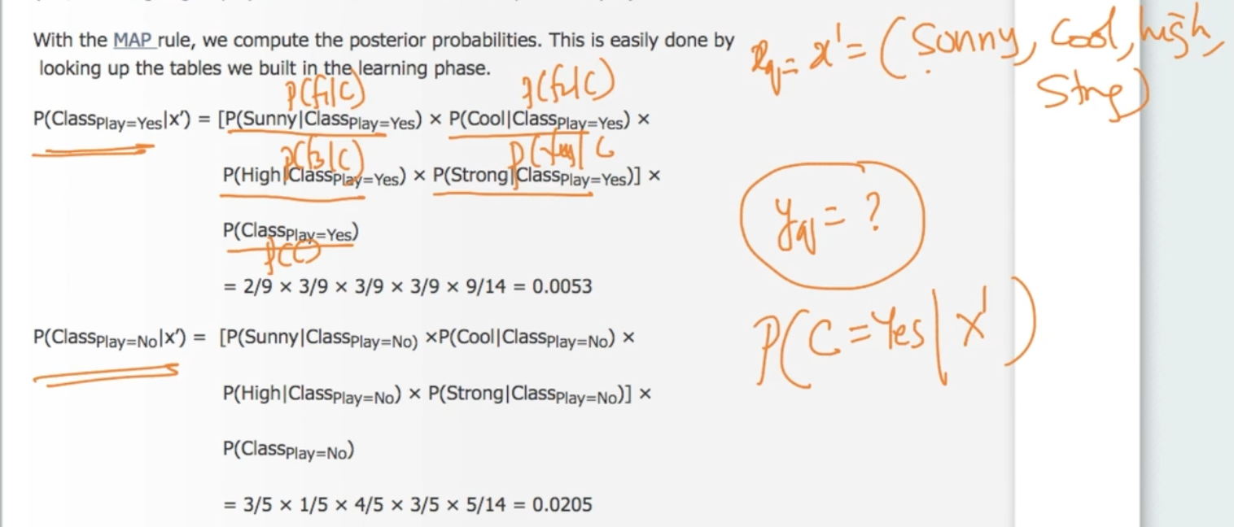

If we are given query $x_{q}$ our $y_{q}$ can be calculated very easily since all of the probability features we need are stored in a lookup table (Dictionary). Storing the Query as Key and Probability in value in key- value pair

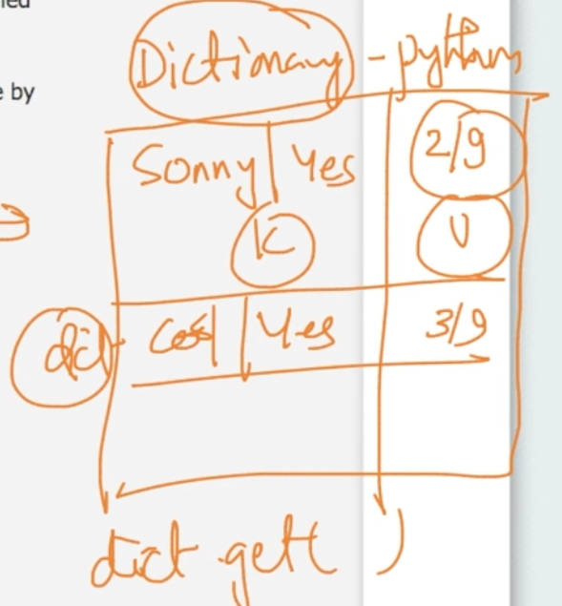

Look up table with key = Query (f | C) and Value = Probability score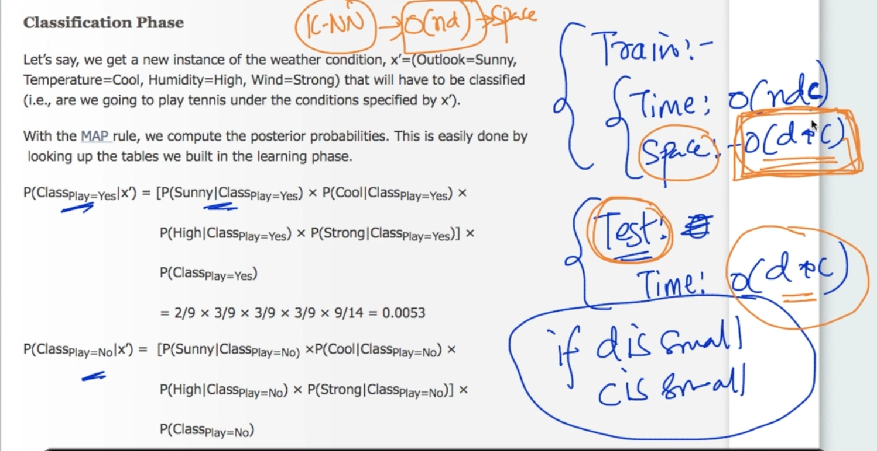

Space Complexity : O(d * C) here d = 4 and classes = 2 so only 8 values in lookup table

It’s much better than k-NN which has Space Complexity O(nd). We don’t need to bother our points as we can directly look at the lookup table

# **NAIVE BAYES ON TEXT DATA**

Naive Bayes is popular for text classification like Spam Filter

Suppose we have a text data with its class labels . Our task is to predict $y_{q}$ with text query ${text}_{q}$. We calculate P( $y_{q}=1 | {text}_{q}$) and P( $y_{q}=0 | {text}_{q})$ 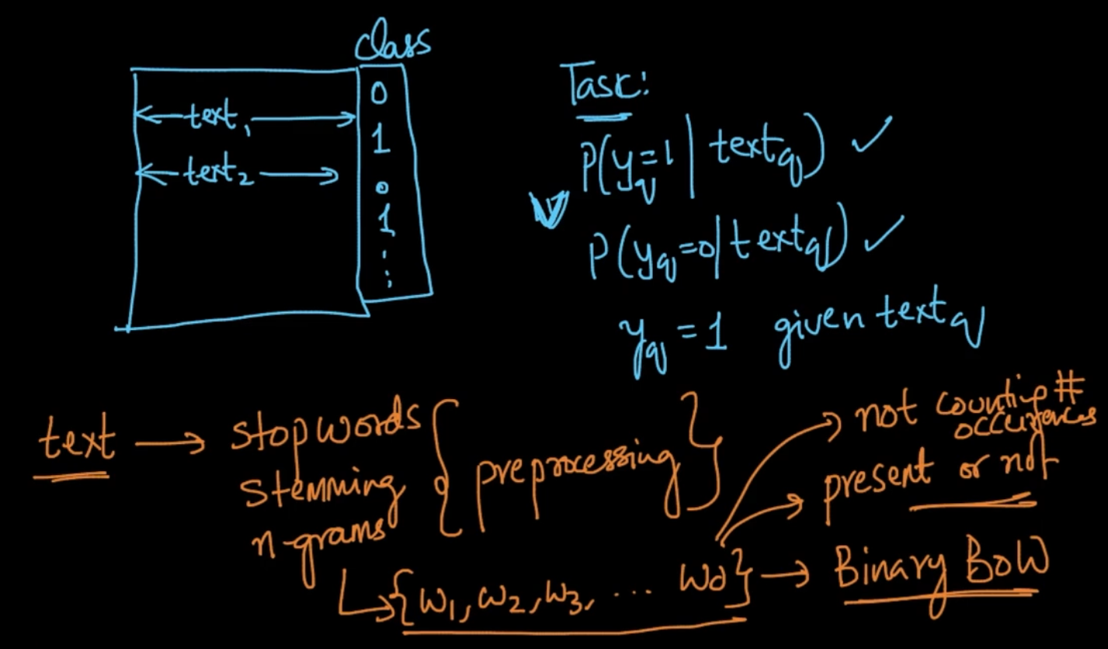

If P( $y_{q}=1 | {text}_{q}$) > P( $y_{q}=0 | {text}_{q}$) then $y_{q}$ = 1

We do the pre-processing steps above on a text and get a set of words {w1,w2….wd} in a Binary BOW representation i.e if the word is present or not

We calculate P( y = 1 | text). Here, P( y = 1) is easy to calculate. Now we want likelihoods i.e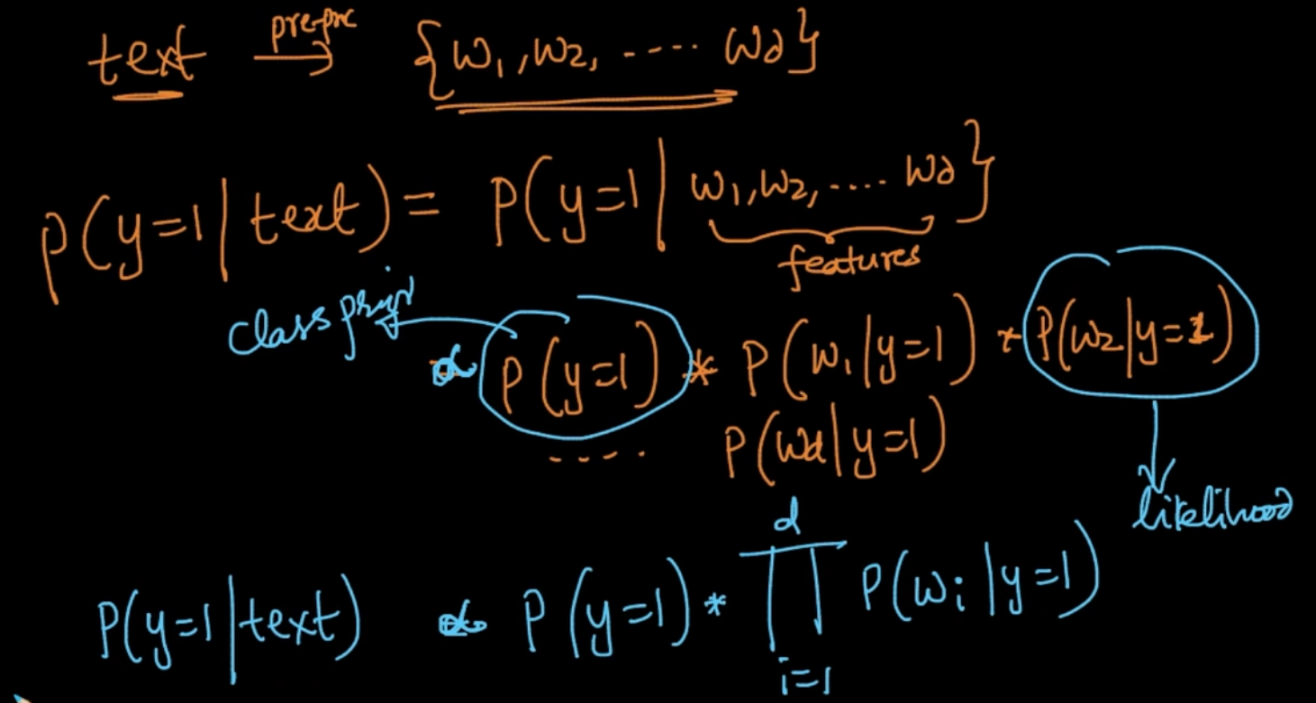

P( w | y = 1). Same things for P( y = 0 | text), just replace y = 1 with y = 0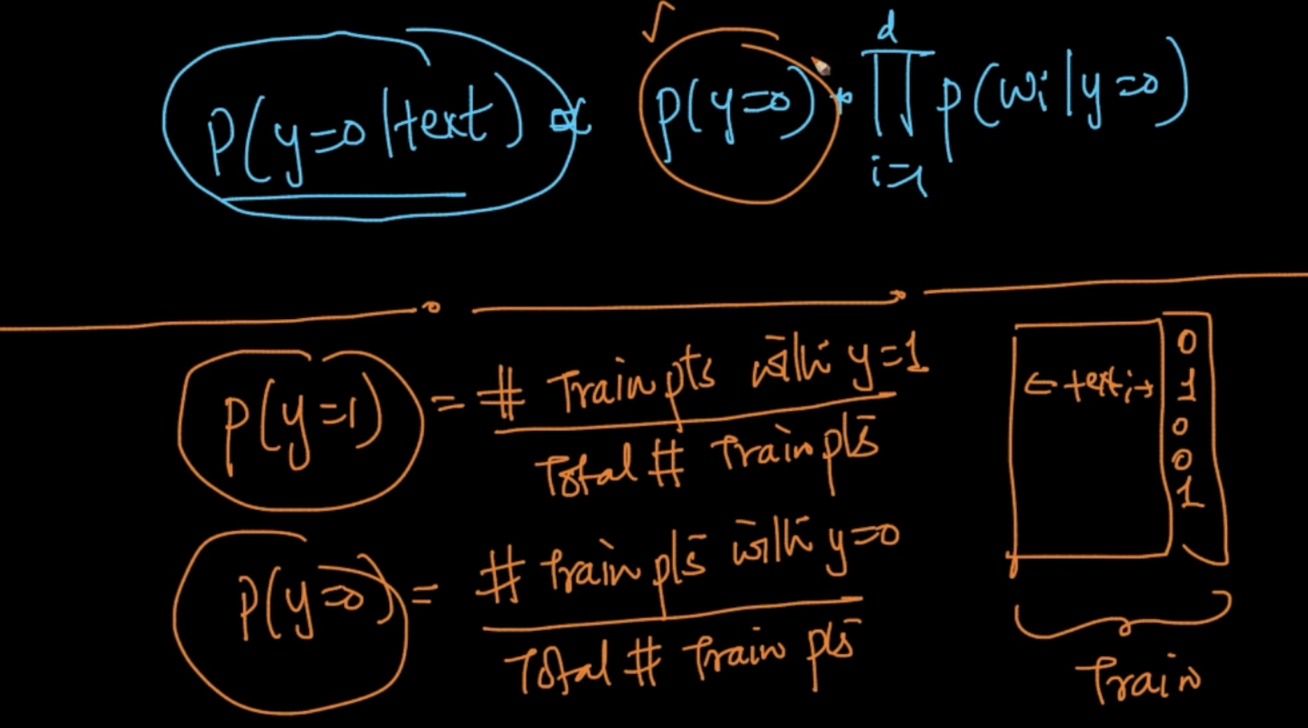

P( y = 1) and P(y = 0) are calculated very easily. Simple counting stuff. We take all the points with y = 1/ Total points

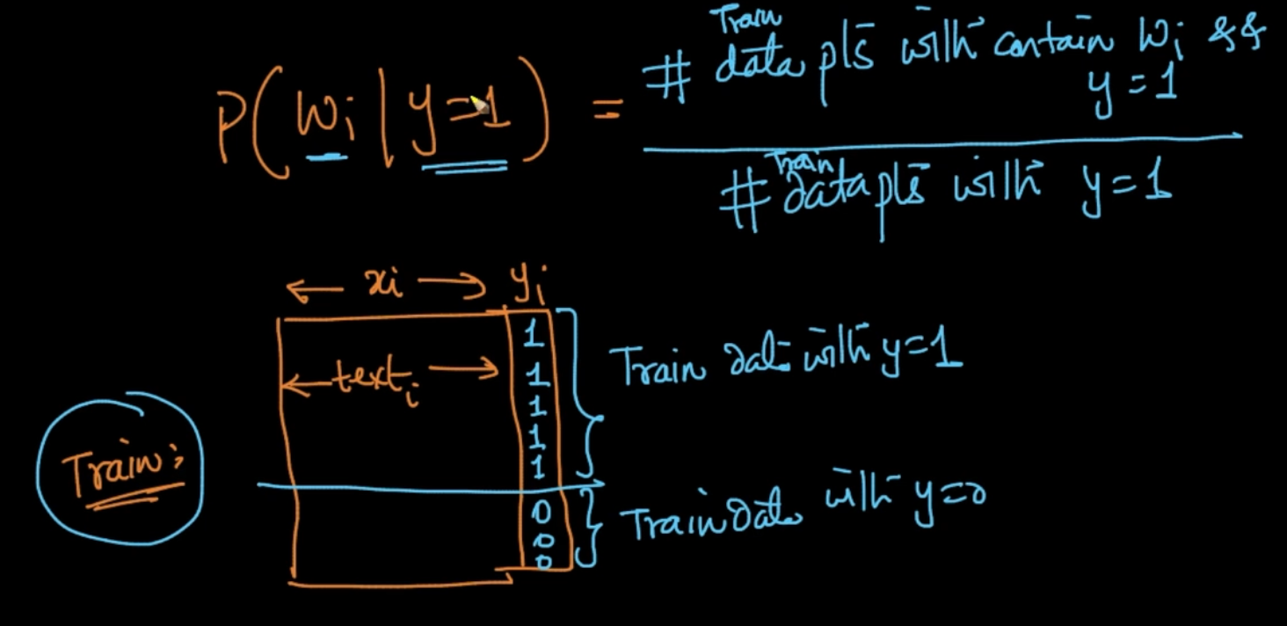

For likelihood calculation, we divide the Train Data with y = 1 and y =0. For P (w | y = 1)

We count all the data points which contain word w and y = 1/ Total Data points with y = 1

Same for y = 0

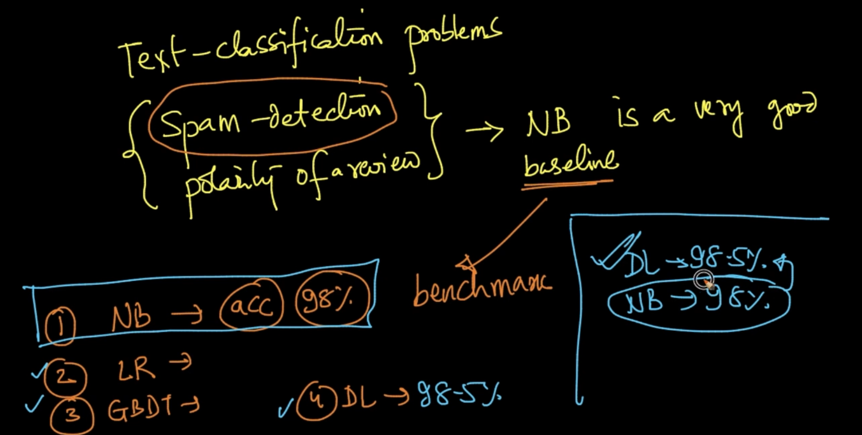

Naive Bayes is a very good baseline and it’s used as a benchmark. Suppose if we get 98% on our simple baseline Naive Bayes and 98.5% on a complicated DL model then we say it’s only a slight improvement

# **LAPLACE ADDITIVE SMOOTHING**

In the training parts, we want to calculate likelihoods and class priors

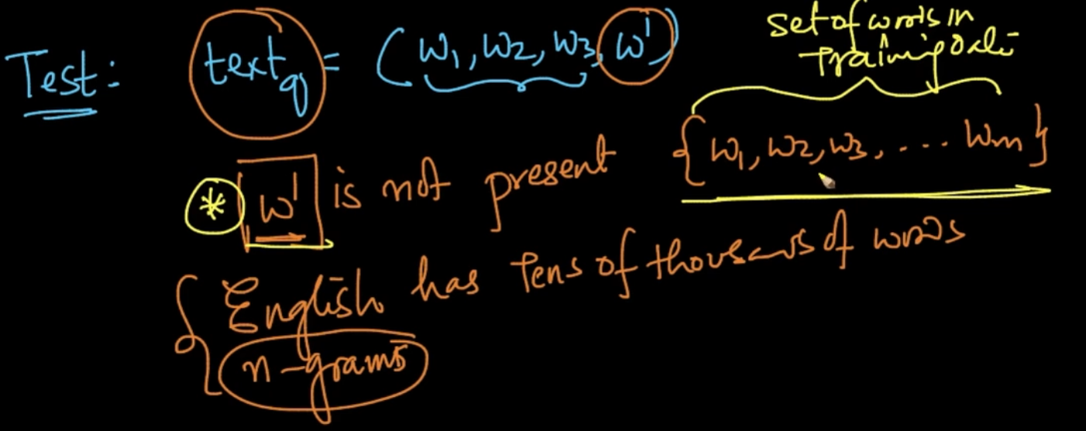

In the testing part if there occurs a word w’ which is not present in set of words of Training data then what we should be doing?

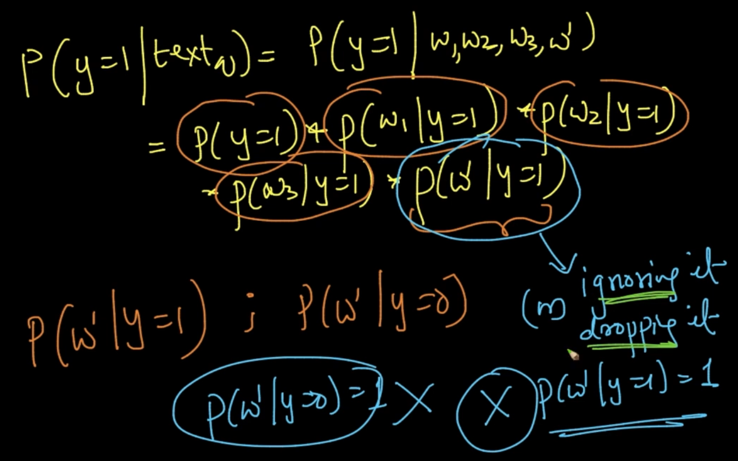

We want to calculate P (w’ | y = 1). What if we ignore it ? It’ll mean P (w’ | y = 1) = 1 and

Also P (w’ | y = 0) = 1 which cant be the case

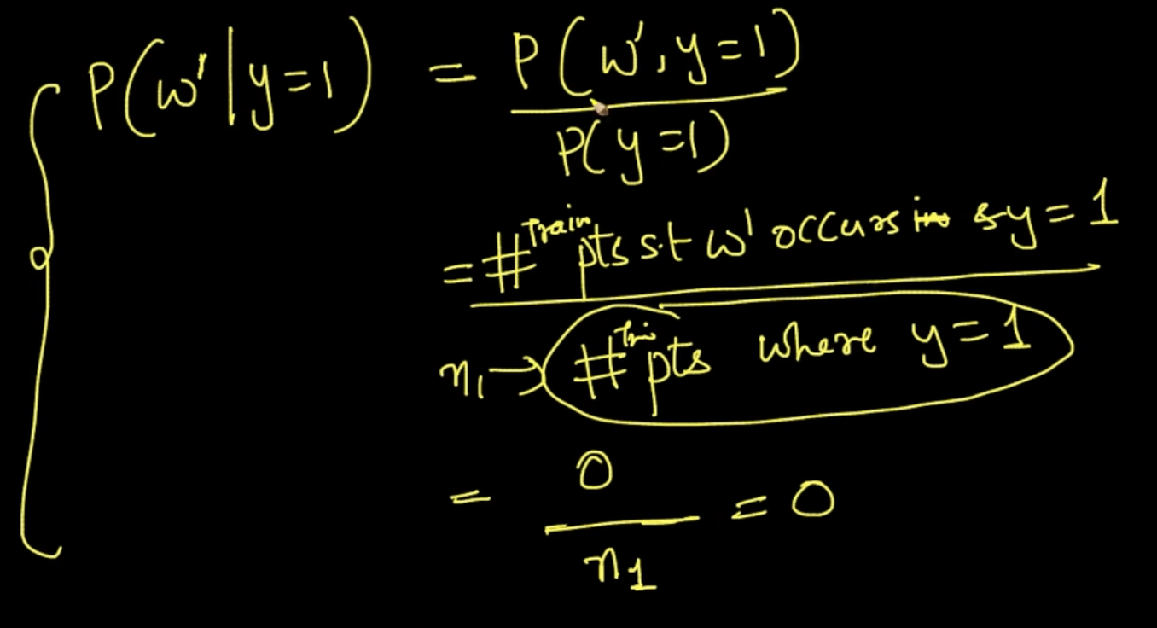

We can’t go for our conditional probability method since w’ is not present which means

P ( w’ $∩$ y = 1) = 0. Therefore all the probability will go to 0. To tackle this we use Laplace smoothing

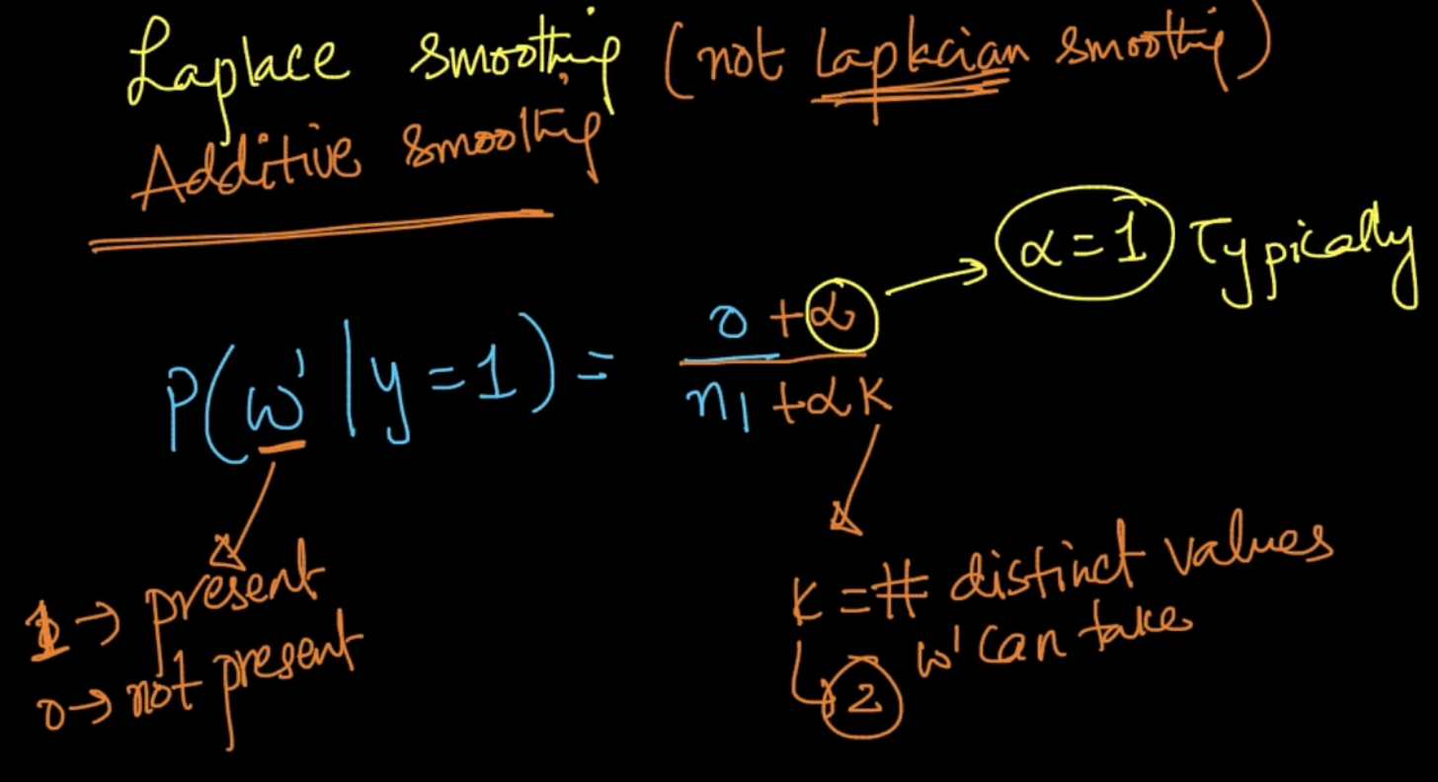

We add $α$ and K for smoothing. K = number of distinct values w’/ feature can take . Here, since it’s a Binary BOW it can only take 2 distinct values (0 or 1) therefore K = 2

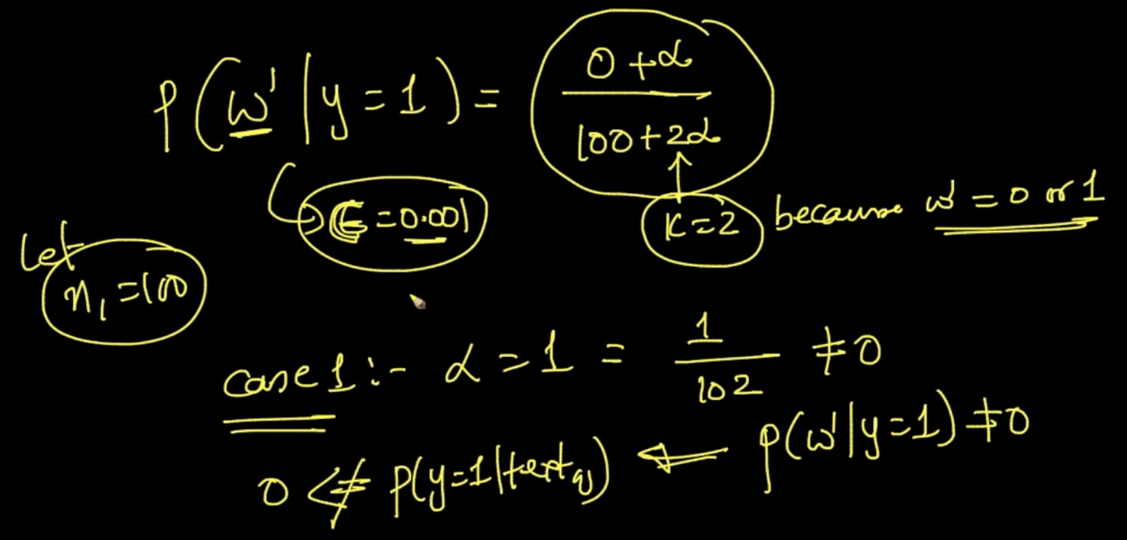

Case 1 : $α$ = 1 . We got rid of the problem of P (w’ | y = 1) = 0. It won’t be 0 anymore but why doing this method. We could’ve just replaced new word w’ probability with a small e.g 0.01

But there are some mathematical insights we can get from this smoothing method

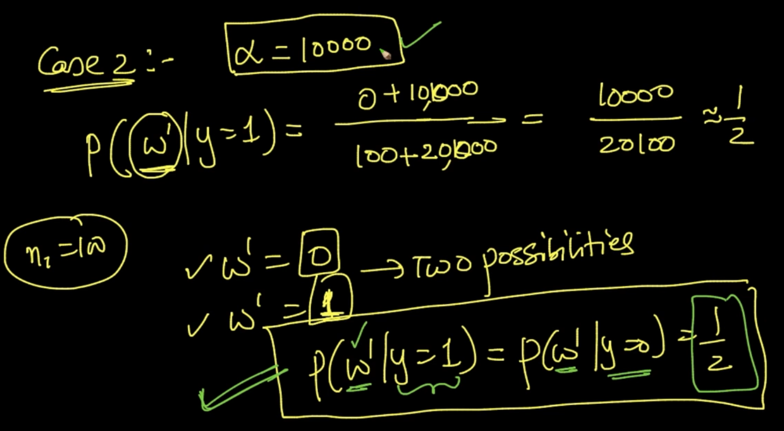

Case 2 : $α$ = 10,000. P $≈$ 1/2 is a good thing and more logical because we don’t know anything about w’ and saying that probability of w’ occuring in both classes = ½ i.e equiprobable is logical. So what happens in Laplace Smoothing ?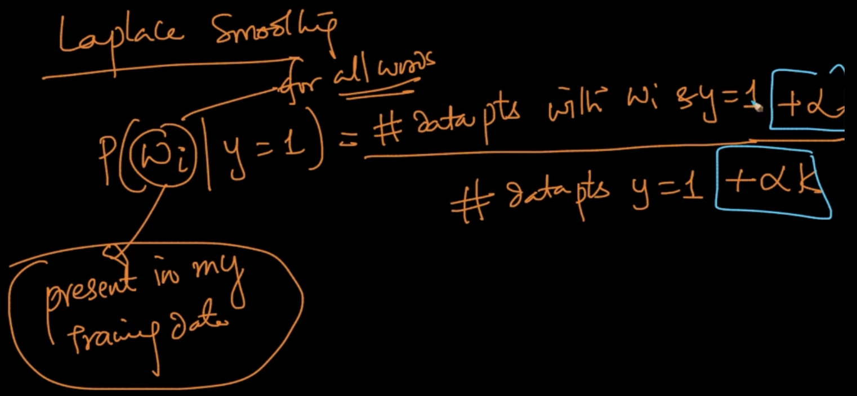

It can be done for words which are present in Training data (set of words) not just new words

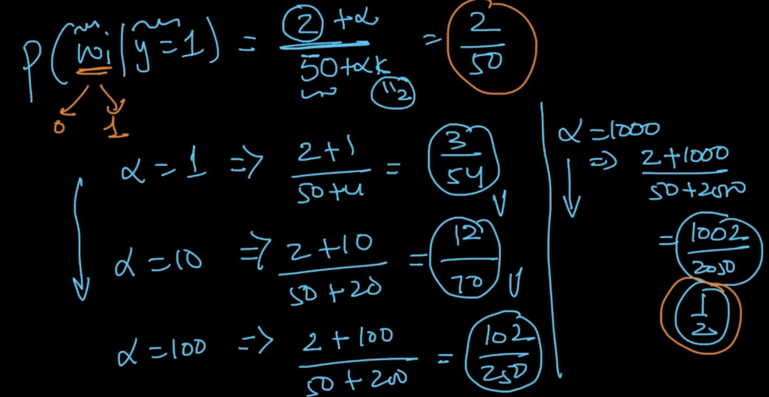

So what is happening when $α$ is increasing ?

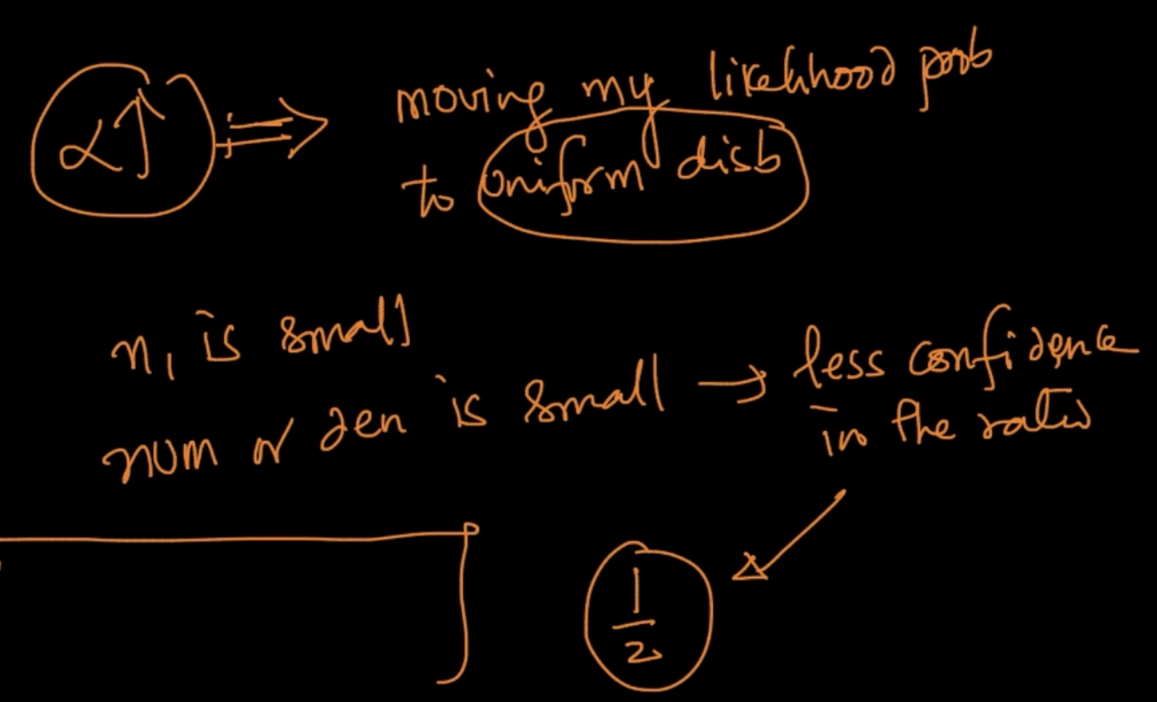

As $α↑$, we move our likelihood probabilities to uniform distribution. If our numerator or denominator is small we’ve less confidence in the ratio. So bu increasing $α$ we are moving towards a stable confidence. In above example, at $α$ = 1000 it is ½ which makes much sense since w’ can only take 2 values (0 or 1) so it has smoothed/ moved to a uniform distribution.

# **LOG - PROBABILITIES FOR NUMERICAL STABILITY**

Calculation for prediction of class label with d = 100 features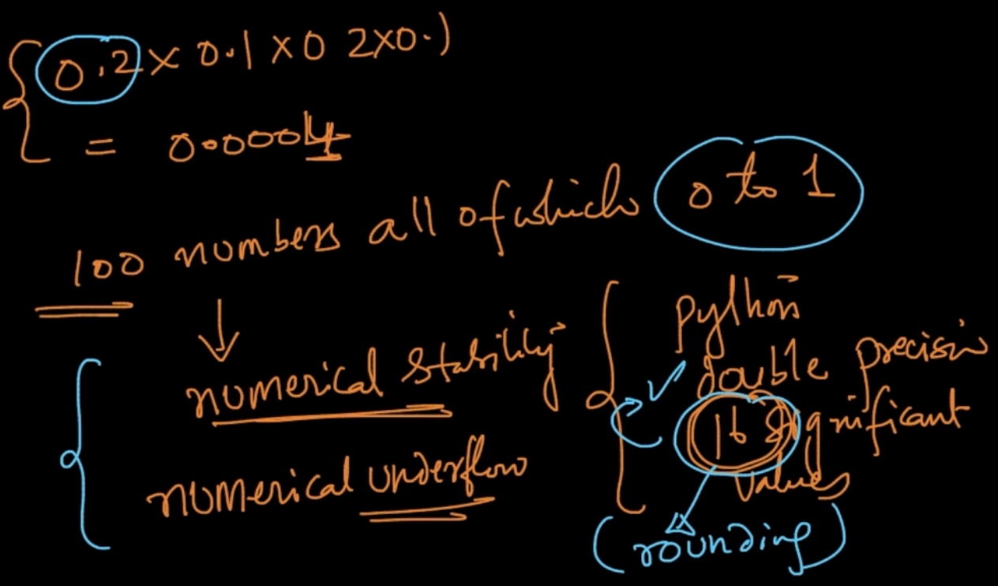

If we multiply 100 numbers that are between 0 - 1 numerical underflow issue arises i.e Python gives only 16 significant values. So with that multiplication it’ll round off to 16 which will give us errors. If we apply log. E.g log(0.0004) = -3.39 things will be easier

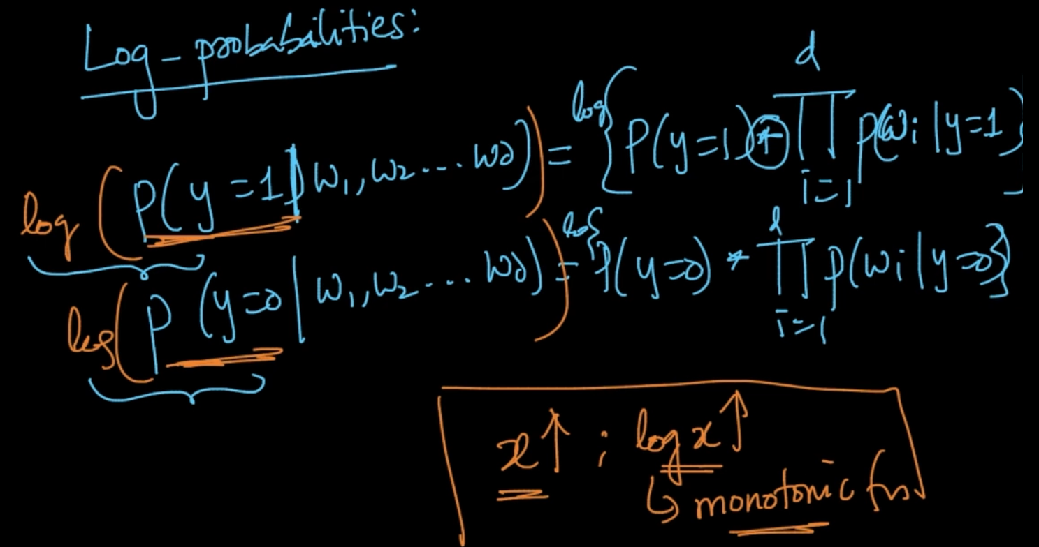

We need to compare P( y = 1| w) and P( y = 0 | w). If we do their log then the calculations will get easier as log is a monotonic function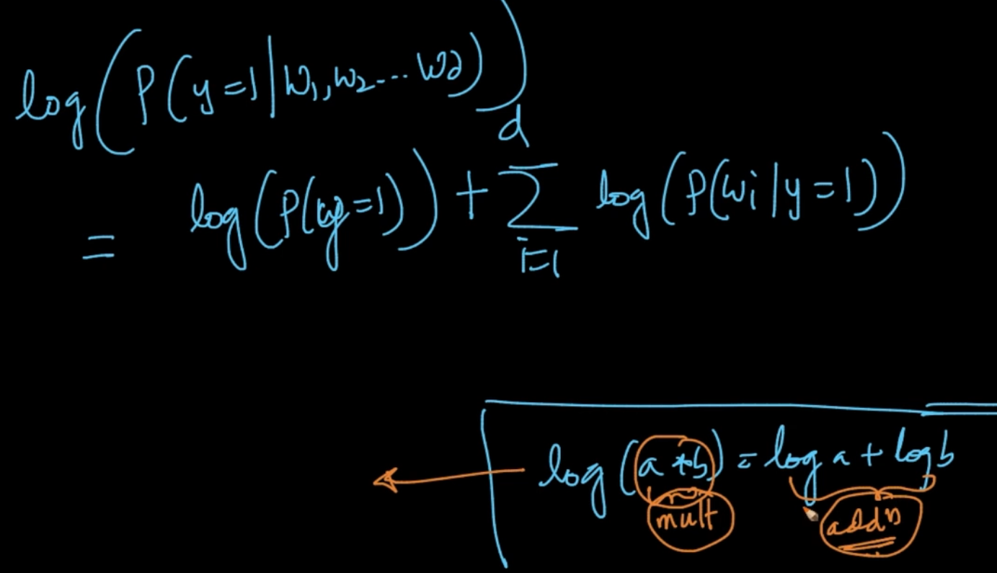

Here it can be seen that calculations are getting easier because multiplication get converted to addition. It also converts exponentiation to multiplication as log($a^{b}$)= b*log a

# **BIAS-VARIANCE TRADEOFF**

In Naive Bayes, $α$ in Laplace smoothing determines high bias or high variance

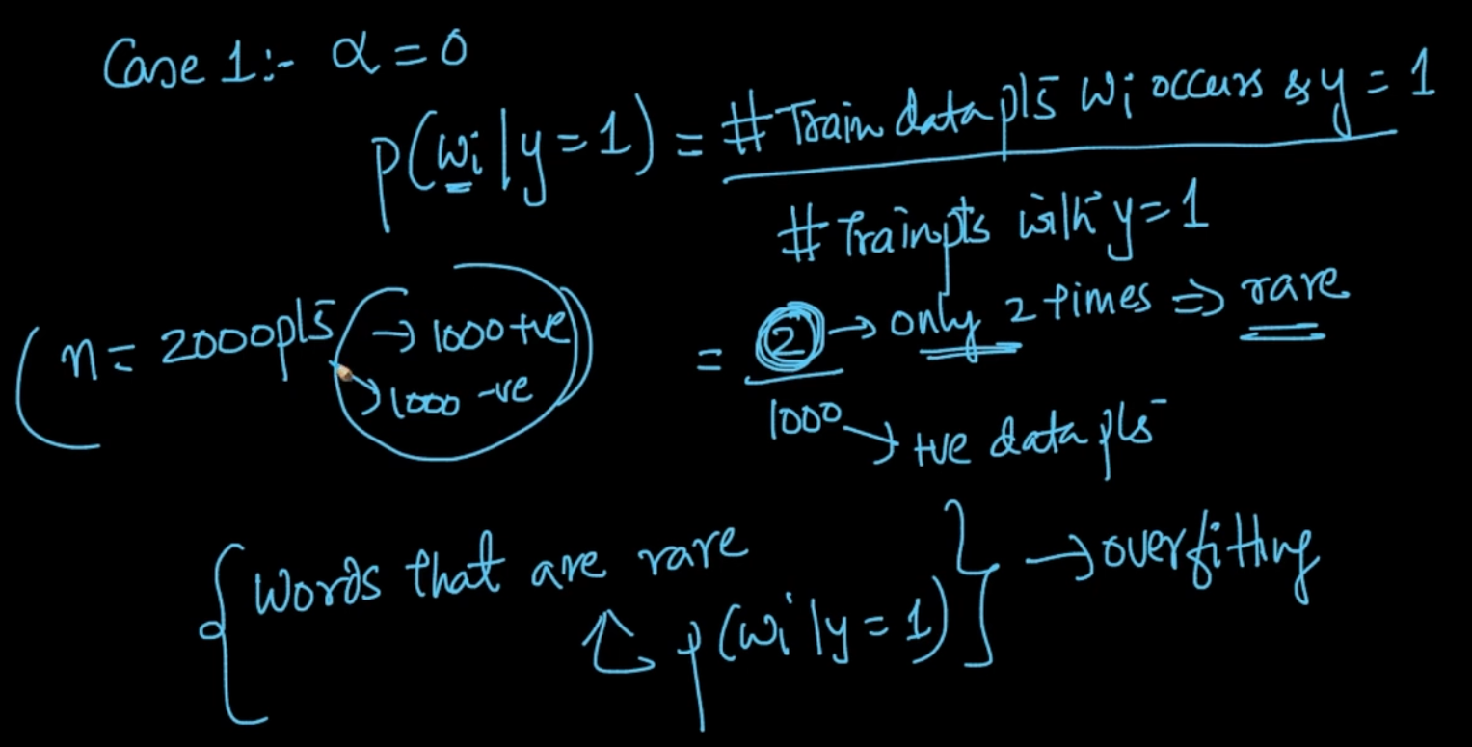

In $α$ = 0 , if there’s a word $w_{i}$ is rare then calculating it’s probability is overfitting in a way

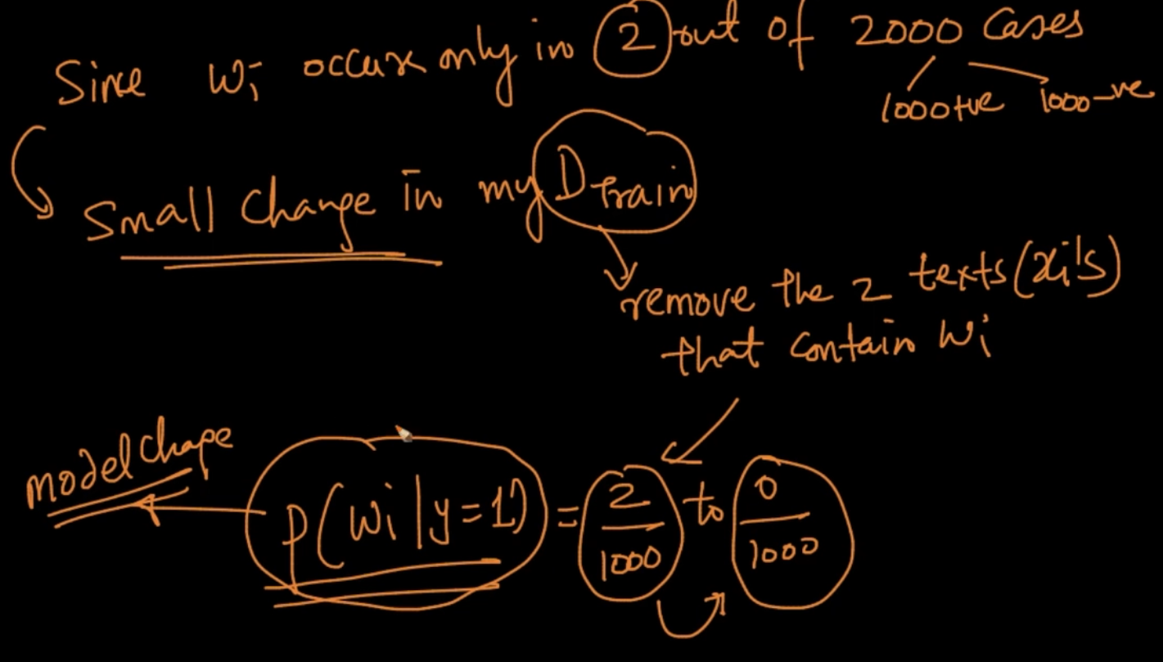

Since there’s no laplace smoothing i.e $α$ = 0 we remove the texts that contain word $w_{i}$

So if we remove those 2 texts our P will change to 0 from 2/1000. It can be said that small changes in Train data result in huge change in model => High variance => Over-fitting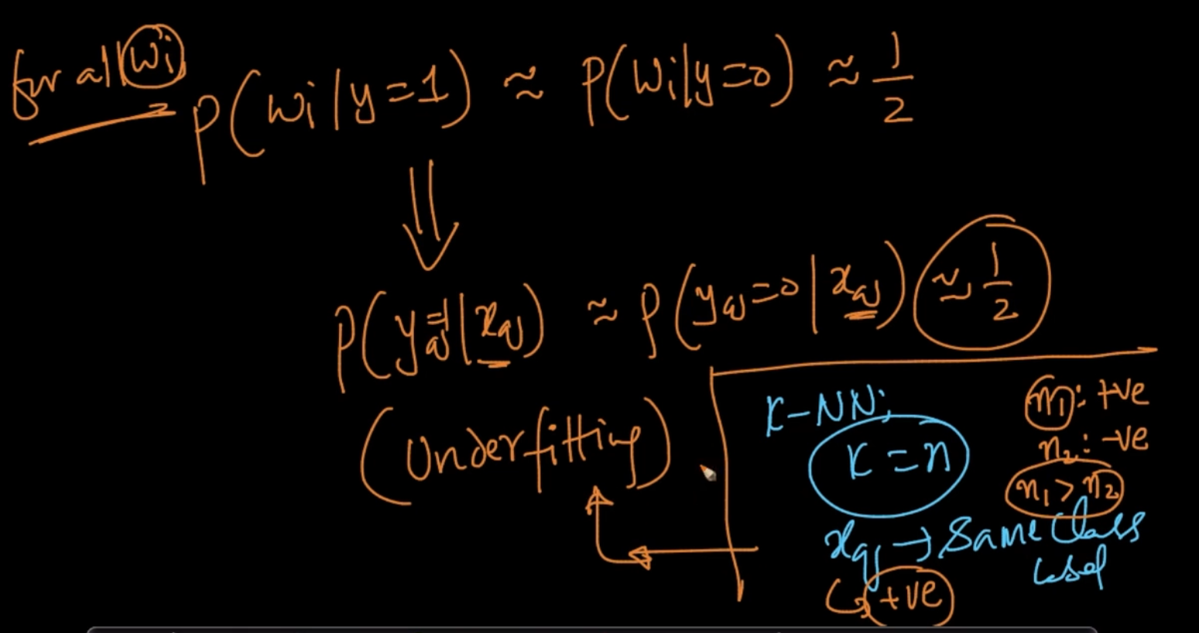

Case 2 : $α$ = Very Large then P (w | y = 1) $≈$ P(w | y = 0) $≈$ ½. Our model can’t distinguish so it’ll be underfitting

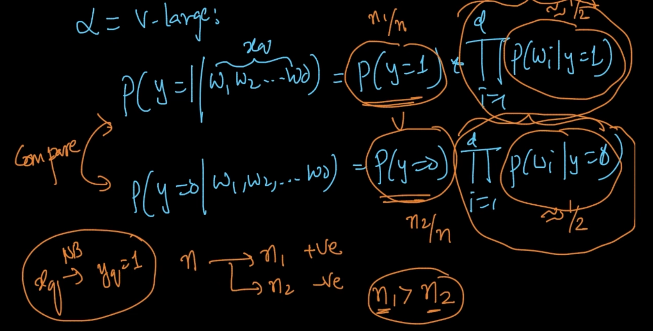

Since P (w | y = 1) $≈$ P(w | y = 0) $≈$ ½ it’s only dependent on P(y = 1) and P(y =0). So, if

Positive class points > Negative class points then for every query $x_{q}$ it’ll predict $y_{q}$ = 1

which is the same as underfitting in k-NN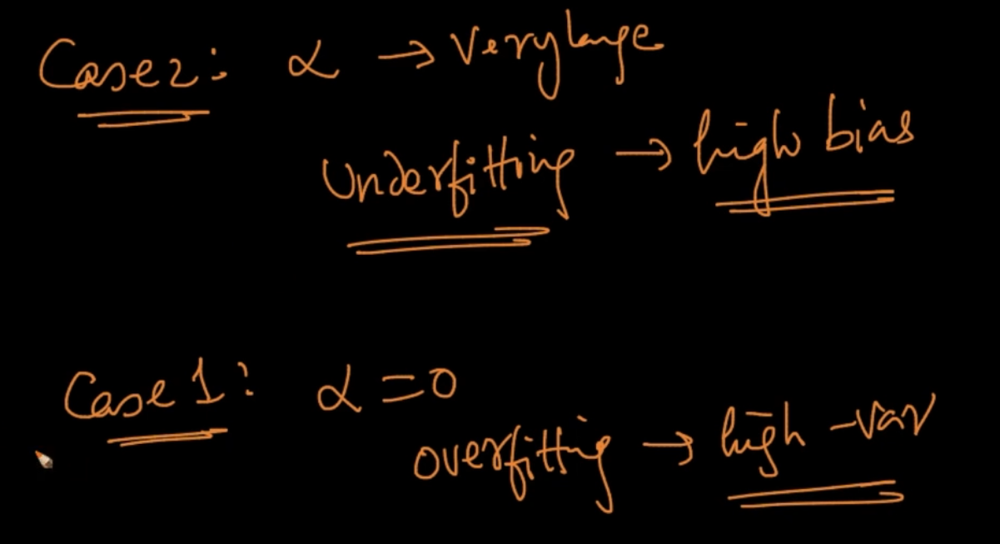

So we need to find the right $α$. So, to find it we do Cross Validation as $α$ is a hyper-parameter and hyper-parameters are decided using Cross Validation(CV)

# **FEATURE IMPORTANCE AND INTERPRETABILITY**

**FEATURE IMPORTANCE**

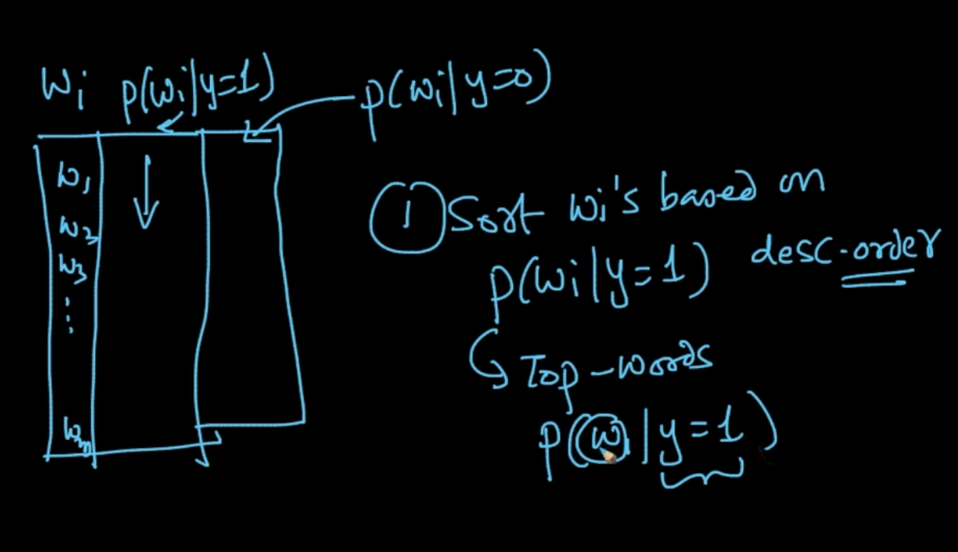

We decide the most important features by Sorting w based on their probability scores

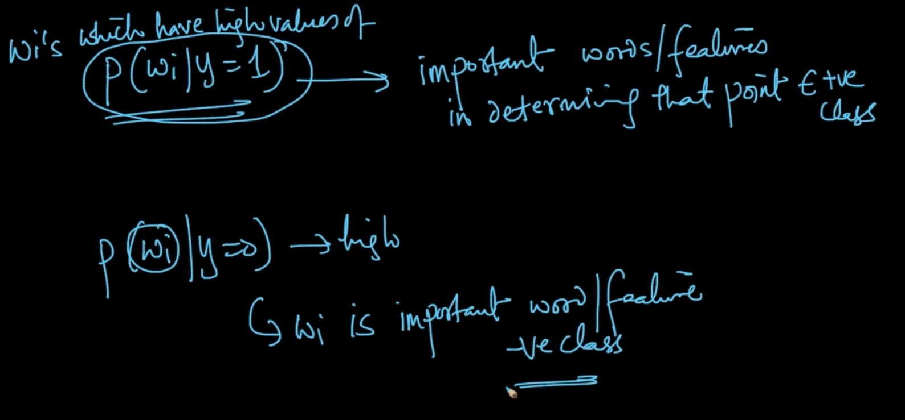

That’s how most important features are decided

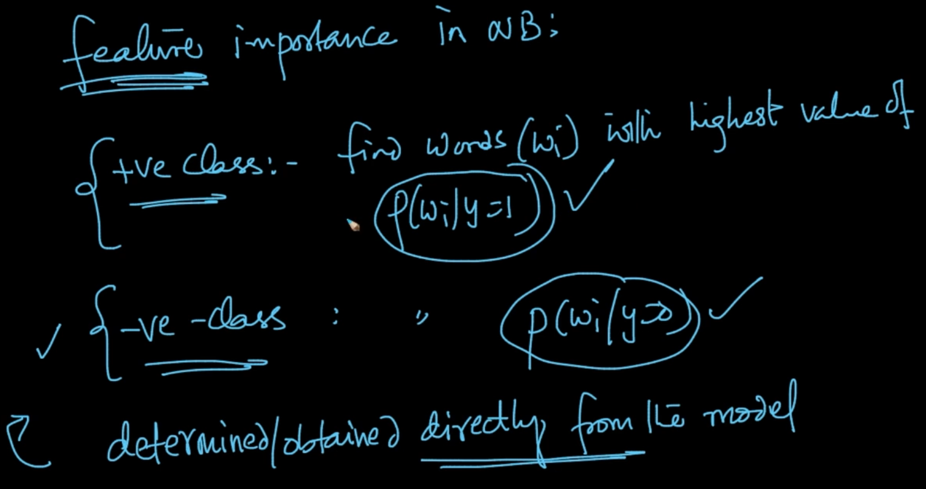

In k-NN, we used Forward Feature selection to select the most important features. Here, we can directly get most important features from model itself since Probabilities are calculated at the learning stage itself

**INTERPRETABILITY**

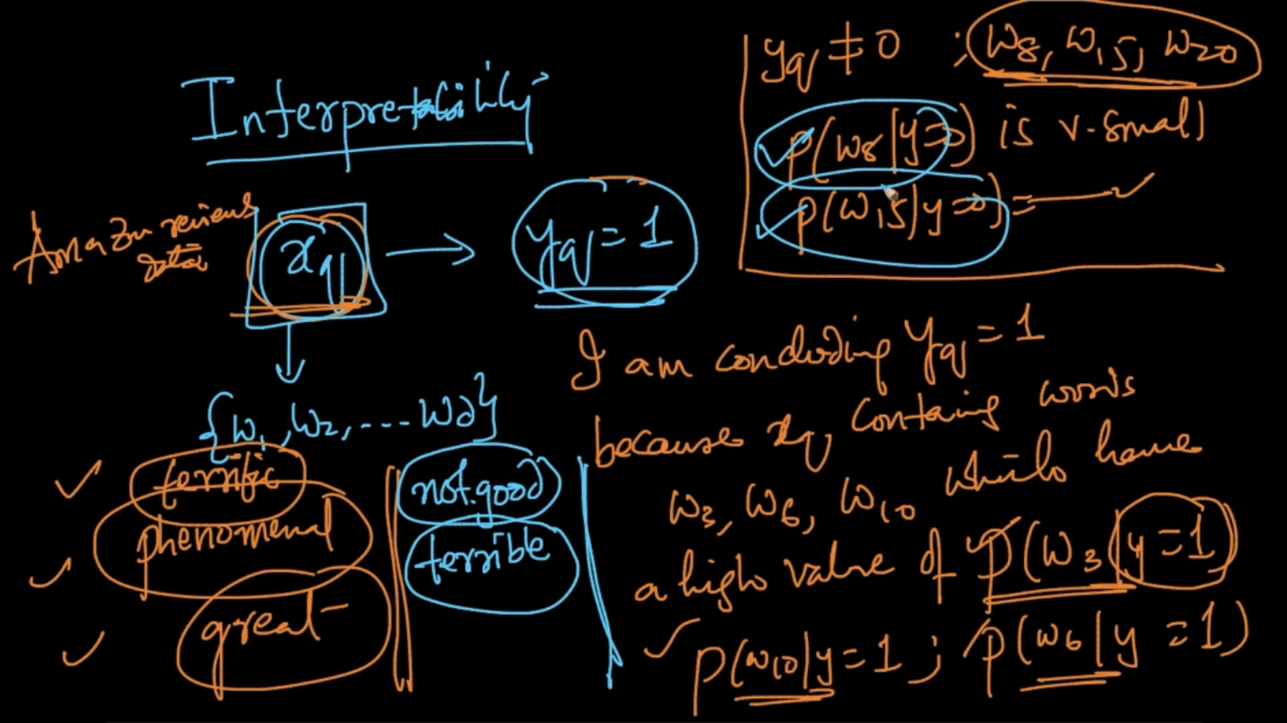

Suppose if we’ve a positive review. We can conclude it’s y = 1 because $x_{q}$ contains words w3, w5, w8 like *terrific, great* which has high probabity score and also conclude y $≠0$ since the probabilty scores of negative words w7, w9 like terrible, not-good are small

# **OUTLIERS**

If a word w’ occurs at test time which wasn’t seen in Train Data then we do Laplace Smoothing to deal with it . It’s an outlier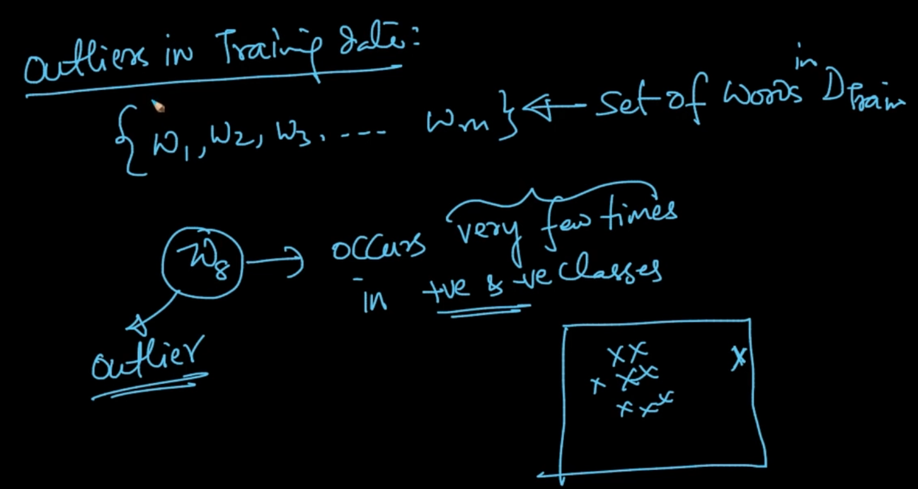

If a word w occurs very few times in our Train data then it’s an outlier. How do we deal with it?

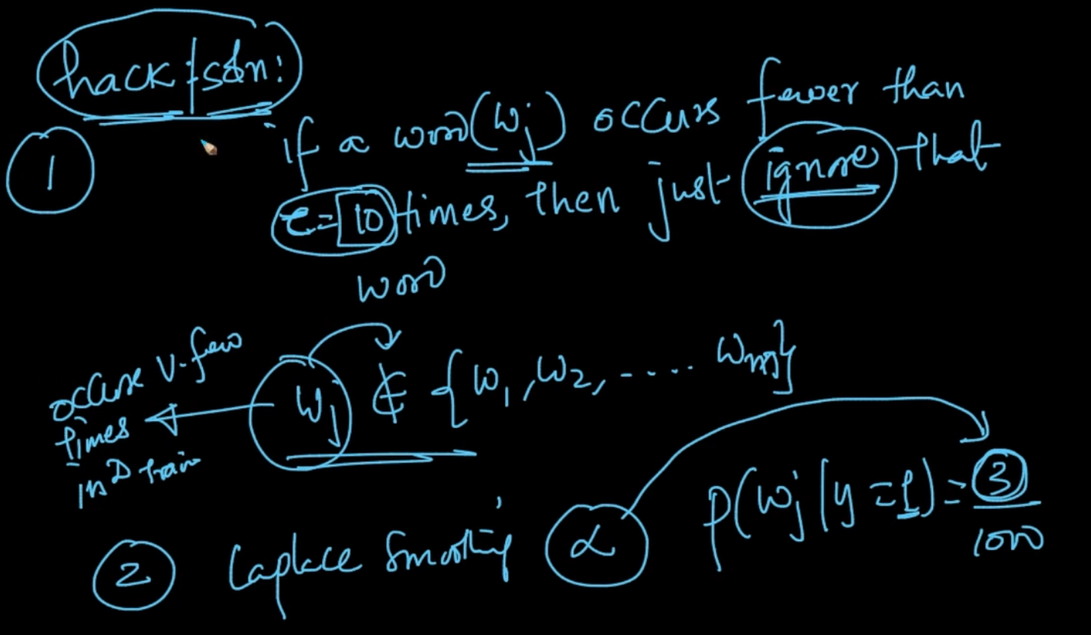

1 ) We can apply a condition/ threshold to just ignore that word as seen above

2) We can use Laplace Smoothing in our Train Data as well with the right $α$

# **MISSING VALUES**

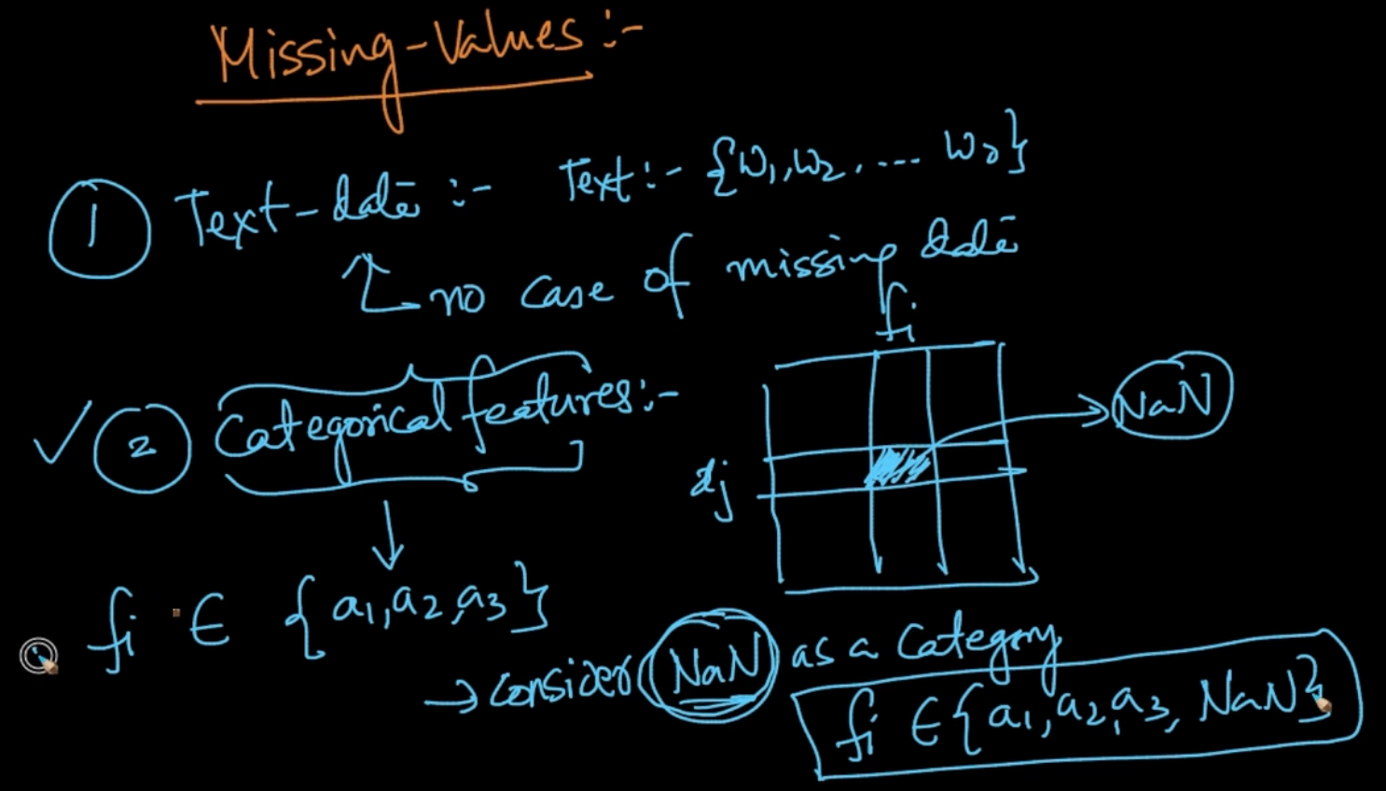

For Categorical features if it doesn’t belong to features {a1,a2,a3} e.g NaN then we also consider NaN as a category. If missing values are there in Numerical data then Imputation

# **GAUSSIAN NAIVE BAYES**

We are seeing Naive Bayes for numerical data. First we’ll divide the data into positive and negative classes . P(y = 1) is easy to calculate. P($x_{ij}| y =1$) is difficult to calculate .It’s our likelihood. It is probability of feature j given our class label

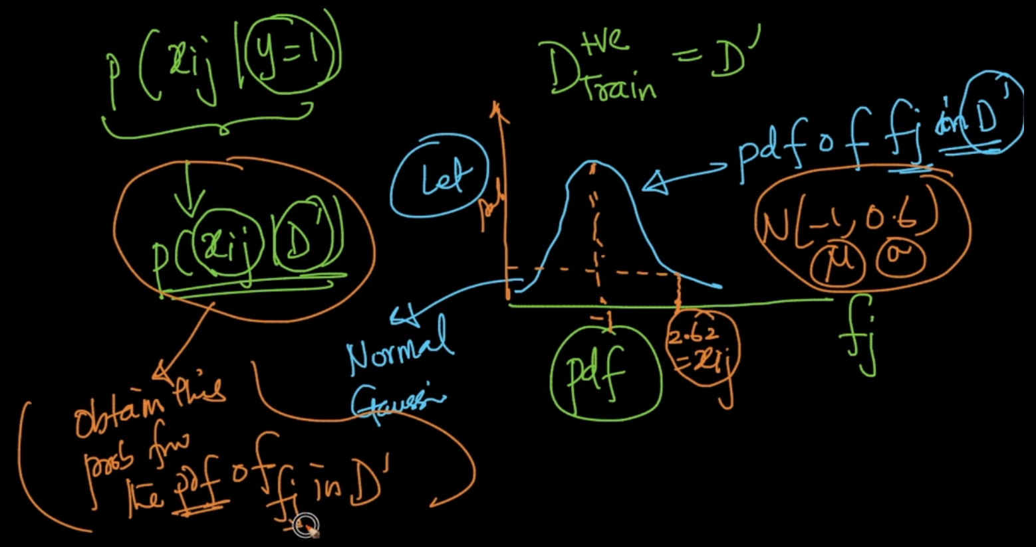

We can predict it by plotting the PDF of a feature j with y = 1. Ex : $x_{ij}$ = 2.62 then we can get the probabilty value by plotting PDF of j since PDF has Probability scores in y-axis

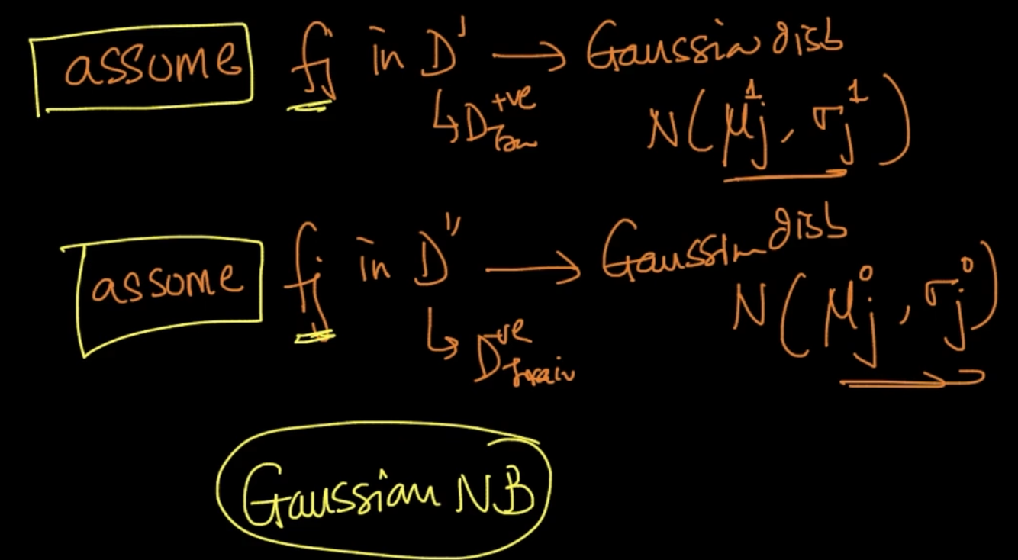

Here we are assuming that our features follows Gaussian Distribution. Therefore, this is called Gaussian Naive Bayes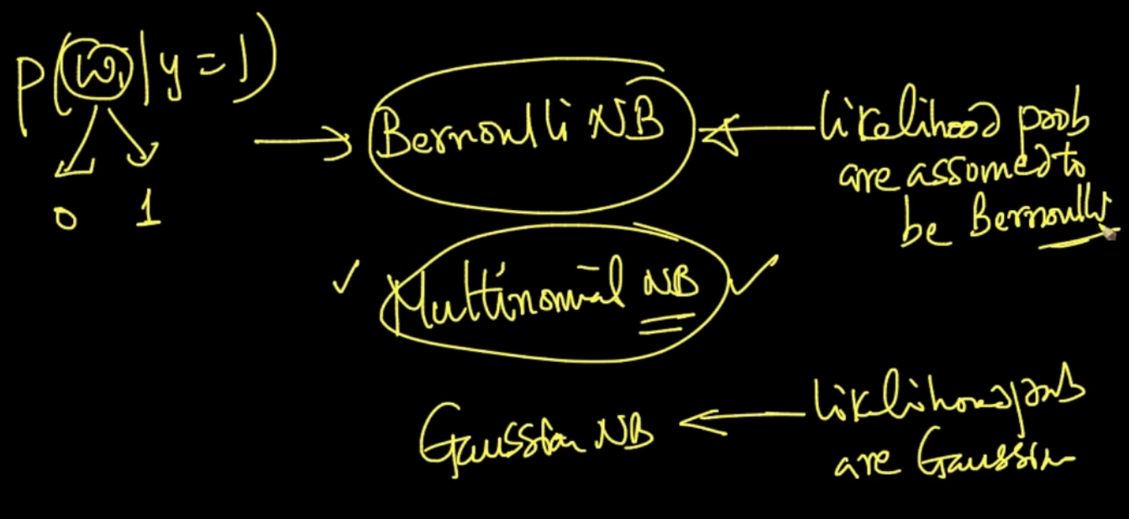

There can be other Naive Bayes as well. Ex: If our random variable x has binary values then it’s following Bernoulli Distribution

NOTE - Naive Bayes’ big assumption is that all the features are conditionally independent i.e the features aren’t dependent on each other

**MULTICLASS CLASSIFICATION**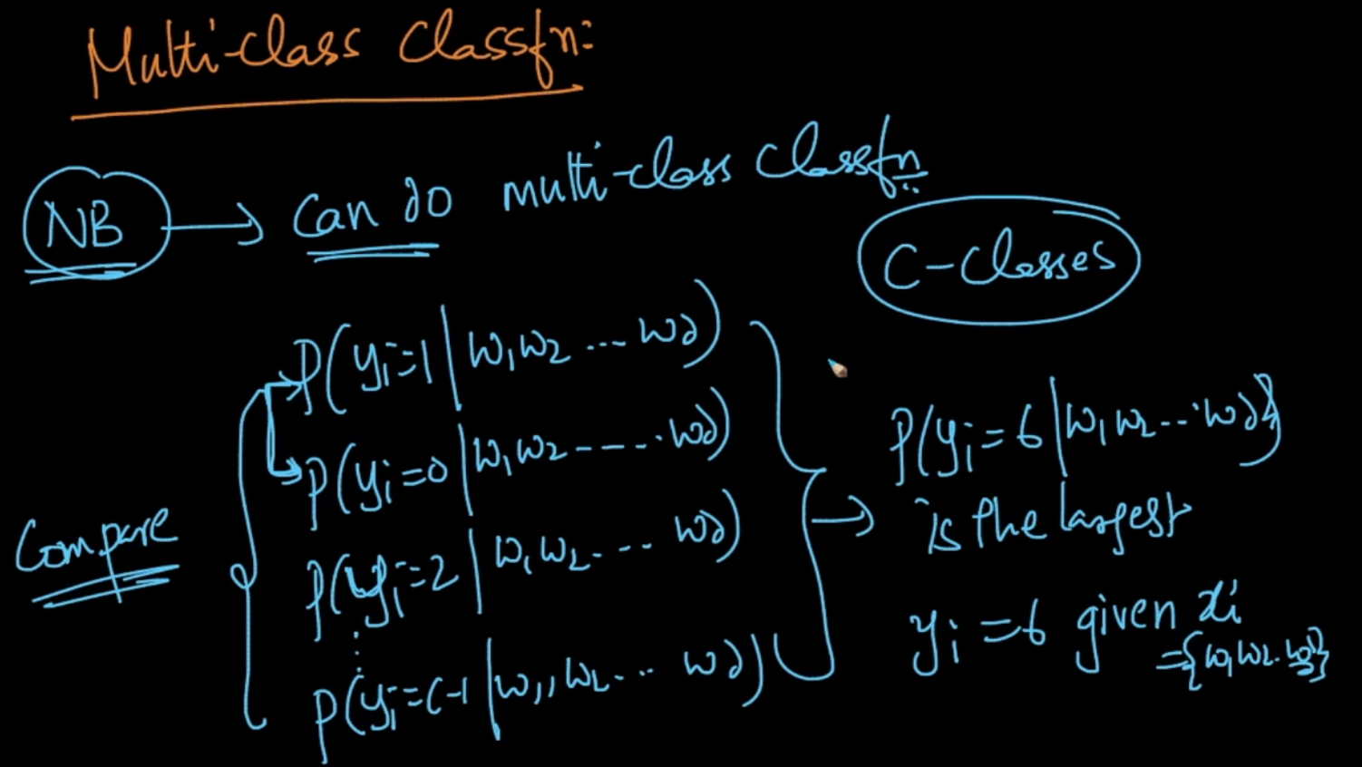

Naive Bayes can do Multiclass Classification pretty well. If we’ve c-classes then we’ll calculate probability scores for all the classes and select the one class which has largest probability in it

**SIMILARITY MATRIX OR DISTANCE MATRIX**

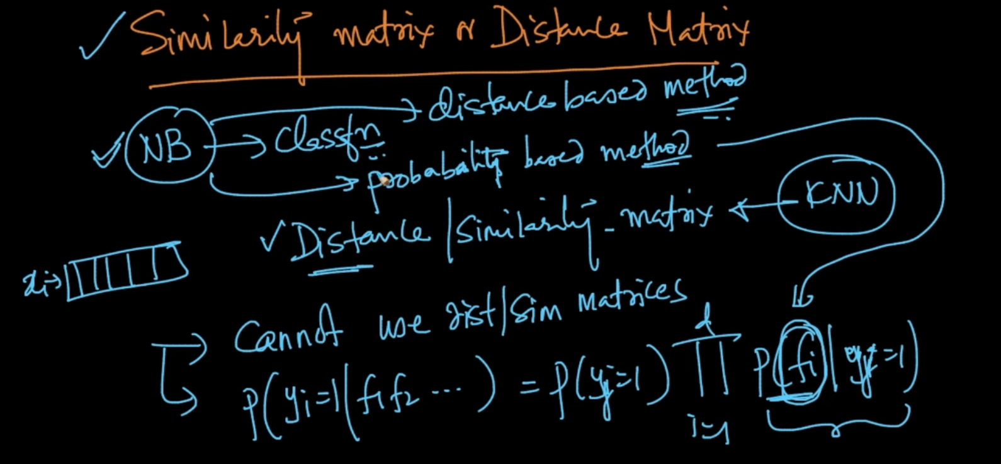

We cannot use distance/similarity matrices in NB as classification is done here on a probabilistic based method.So we need the exact value of the feature unlike k-NN which is a distance-based method which could use Distance matrix to do classification

**LARGE DIMENSIONS**

Naive Bayes can do very good in Large Dimensionality but use Log-probabilities instead of normal probabilities to avoid numerical underflow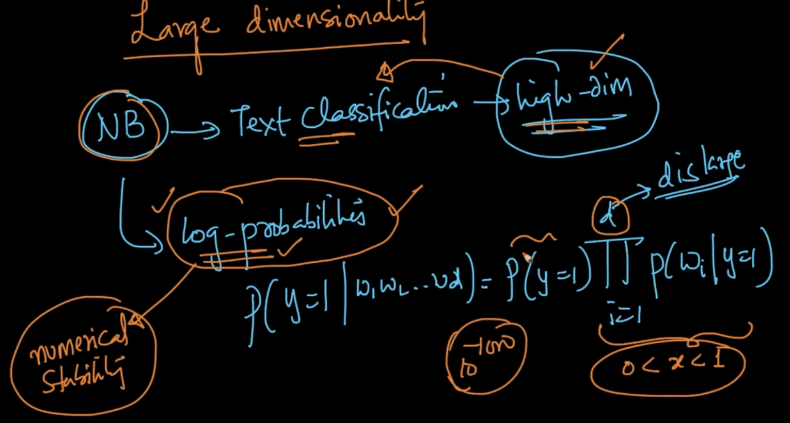

# 

# 

# 

# 

# 

# 

# **BEST AND WORSE CASES FOR NAIVE BAYES**

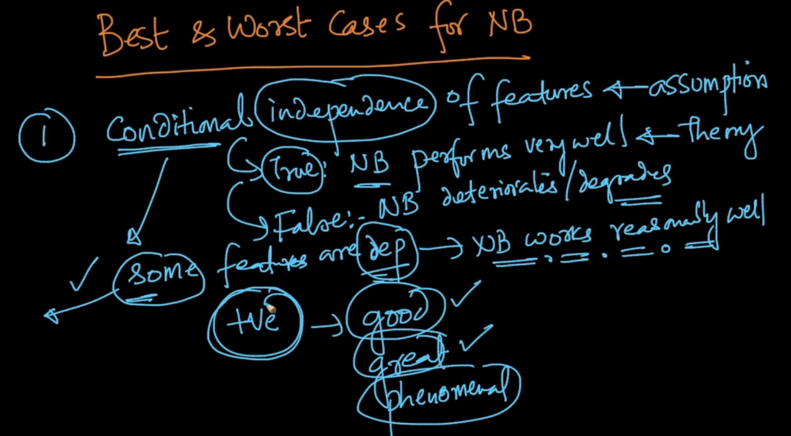

We are assuming that our features are conditional independent. Naive Bayes performs well in conditional independent features but if there is dependence then it deteriorates but if some features are dependent for ex : In review classification words are dependent like if word *good* is there then *great* word can also occur in that NB performs reasonably good 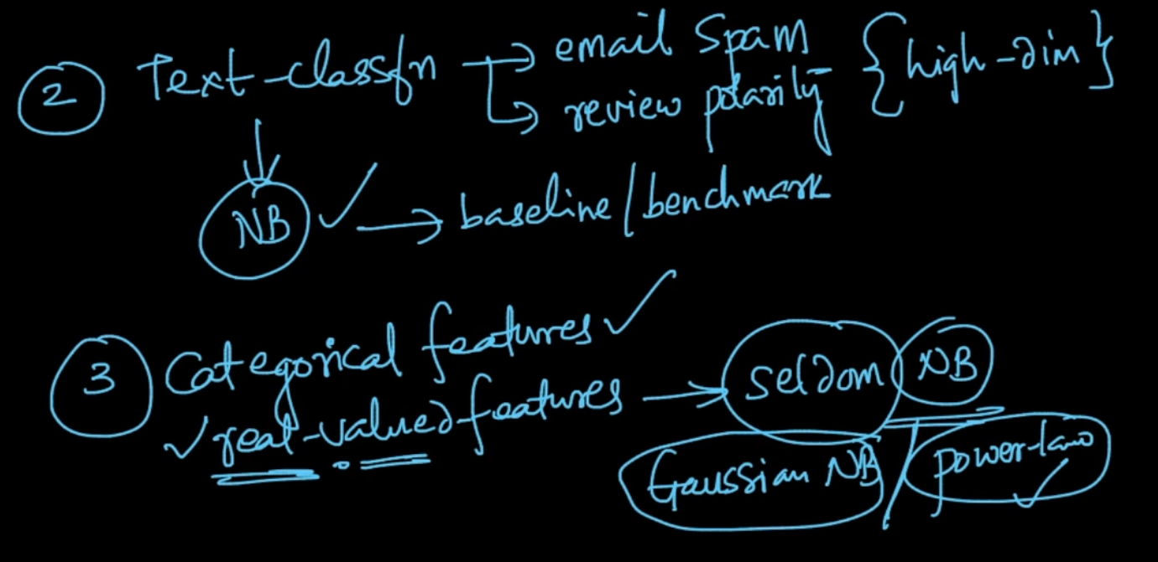

NB performs very well in Text Classification. For categorical features as well but seldom used for real valued features

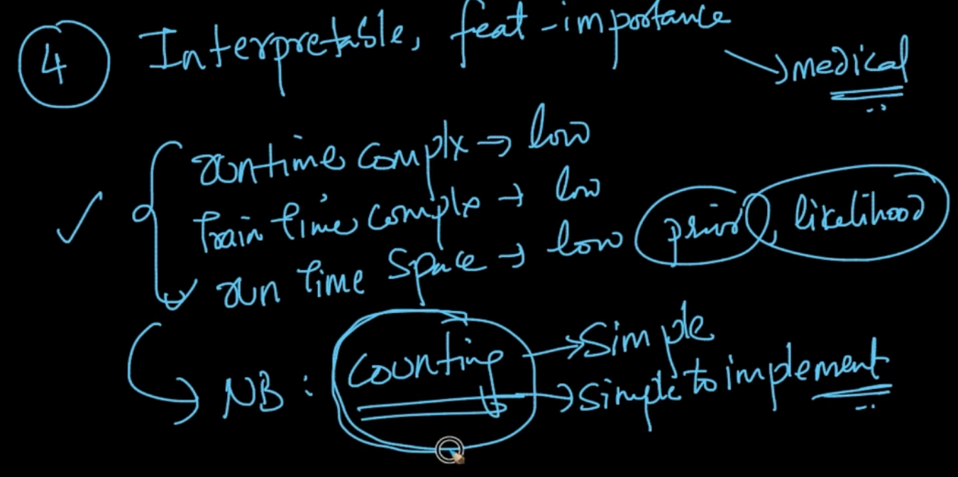

It is very interpretable. Since it’s just counting it is simple to implement and all the complexities are low.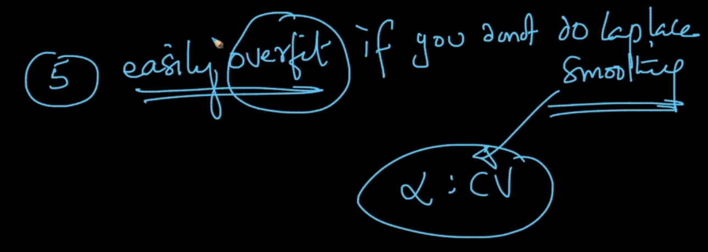

Laplace Smoothing is necessary